November 2017
THE U.S. CALCIO SAN PELLEGRINO SPORTS FACILITY: AN ILLUSTRIOUS PAST FOR A BRIGHT FUTURE
In San Pellegrino Terme, the Football Innovation team takes to the pitch: the quantity of light across the entire surface of the playing field has been tripled, slashing energy consumption by two-thirds.
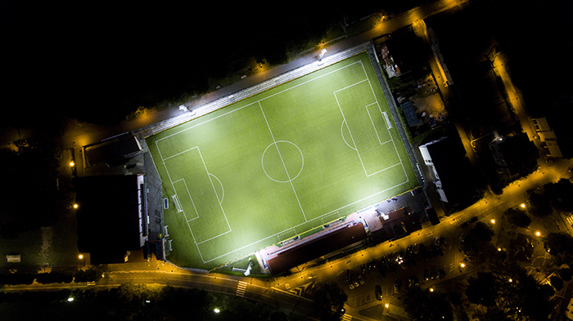
In the heart of the Valle Brembana in the province of Bergamo, visitors can admire one of the most important historical thermal baths in Italy, a place which reached international renown over the course of the twentieth century. In the midst of the Belle Époque era, the Terme (baths), the Grand Hotel and the San Pellegrino Casino played host to some of the wealthiest members of European society: sparkling examples of Art Nouveau architecture that would go on attracting actors, royals and Italian literary Nobel prize winners over the subsequent decades.
The Football Innovation team was summoned to this charming setting to help place the U.S. Calcio San Pellegrino (football sports association) facility in the best possible light. Three years ago, this imposing structure underwent a host of major works - first of all, the playing field was resurfaced with synthetic turf, then attention was turned to the stands, which can now accommodate more than 3,500 spectators. Finally, the project to update the pitch lighting was rolled out, significantly improving the quality of light both for athletes and spectators.
"We decided to modernise the entire structure," explains Stefano TASSIS, Sports Director for the U.S. Calcio San Pellegrino facility, "because we want to provide all of our athletes with the best possible conditions in which to express themselves.. Our sports association serves as a point of reference for all young athletes within the entire community of Valle Brembana: in just ten years, our membership numbers have doubled, and today we have 290 athletes, ten teams, and around 50 technical and managerial staff. We are acutely aware of the important role that sport plays in the growth and development of new generations, and we have chosen to invest in the quality of our coaches, including those who train our youth teams: today, our football school represents the feather in our cap, with around forty young athletes who have made the journey from the Pulcini (juniors) to the Allievi (rookies), with single-class teams. This investment has enabled us to build a very close-knit group, as well as allowing us to clock up a number of major sporting achievements: in the last three years alone, we have won ten championships in the youth sector, and this year we will have three teams in the Giovanissimi, Allievi and Juniores regional championships”.
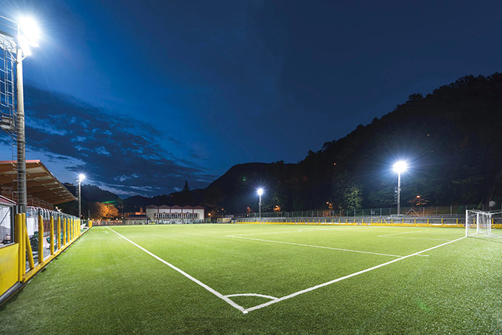
The operation to modernise the San Pellegrino facility lighting system was carried out by a team of GEWISS and CORUS experts. The members of the Football Innovation team monitored the project activities as they developed, from the initial energy audit to the design process and the actual implementation of the solutions.
"The previous lighting system," explains Davide BONALUMI, CEO of Corus, "was built in the 1980s, and really wasn't suitable for the San Pellegrino pitch: the lighting levels in the midfield area were recorded at a mere 50 lux, while near the corners, the figure was just 30 lux. Accordingly, we decided to install seven Smart [PRO] LED devices with two modules on each of the four existing lighting towers, with a system power of 340 Watts each - compared to the metal halide luminaires used previously, which each had a system power of 2,200 Watts. This enabled us to meet the lighting parameters stipulated by the LND regulations: the results gave much more consistent and uniform lighting across the pitch, and a more realistic light quality. We succeeded in tripling the amount of light across the entire surface of the playing field, slashing energy consumption by two-thirds. Indeed, total consumption has dropped from 26,400 Watts to the current figure of 9,520 Watts: this equates to a 64% reduction in energy consumption. Assuming that the lights are used for 5 hours a day, on 220 days of the year, the hypothetical bill of more than 7,000 Euros is cut to just over 2,600 Euros, allowing the cost of the operation to be offset within just 36 months after implementation. Moreover, by replacing the luminaires, we have also been able to redefine the order in which the lights are switched on, bringing the electrical system in line with regulations to ensure proper operation and use of the structure”.
All the advantages of GEWISS LED technology are embodied in the results of this ambitious project: light quality, visual comfort, safety during play, reduced operating costs, and fast payback. "And maintenance," adds Bonalumi, "is virtually non-existent, because the floodlight guarantees high levels of luminous flux for over 75,000 hours of operation. In addition, the product also comes with a full five-year guarantee, two key factors that enable us to safeguard our initial investment" .
Besides the involvement of the sports association, the relamping project was also supported in a tangible way by the Municipality: "As the municipal authority for this area," says Tassis, who is also Councillor for Tourism for the Municipality of San Pellegrino Terme, "we have supported the investment designed to modernise the lighting system, sharing the energy consumption costs with the association. This public-private partnership has enabled us to find the right balance with regard to costs, generating social benefits which have a positive effect on the entire community."
BOX - FOOTBALL INNOVATION, A SIMPLE STRATEGY FOR WINNING RESULTS
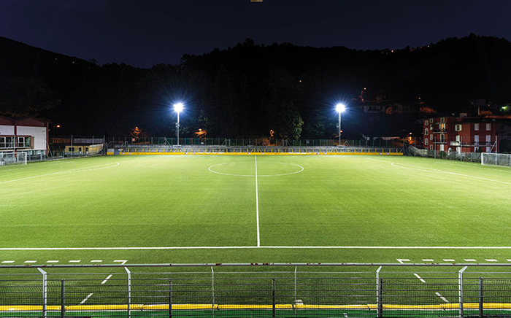
The product of the successful collaboration between the Lega Nazionale Dilettanti (LND, or National Amateur League in English), GEWISS and CORUS, the FOOTBALL INNOVATION project provides amateur sports associations with a range of solutions regarding systems for lighting pitches, changing rooms, stands, car parks, technical premises, warehouses and offices, as well as devices for controlling, managing, protecting and distributing energy in all of the indoor and outdoor areas of sports facilities. Several decades of experience and expertise allow GEWISS to offer more than 20,000 products to meet all requirements in any application context. The contribution of CORUS, a key GEWISS business partner, is crucial in all activities relating to the diagnostics, design and creation of systems within LND sports facilities, combining the quality of GEWISS products with the expert engineering skills, qualifications and certifications required in order to implement and maintain structures of this type.
Directors of sports club can sign up at www.footballinnovation.it, and will be supported through every stage of the process: The CORUS team will provide full assistance at each step of the way, from the first technical inspection of the site and the financial bidding process to the installation of the systems and the management of relationships with local administration and financial assistance bodies, which can enable sports associations to pay off the entire cost of operations in 60 consecutive monthly instalments. CORUS can be contacted by email, at footballinnovation@corusitalia.it, or by phone, on the freephone number 800901015 (within Italy).

