November 2016
90 IDP RANGE: RELIABILITY AND High Performance
The new 90 IDP range by GEWISS offers reliable and high performance solutions for both residential and heavy environment installations.
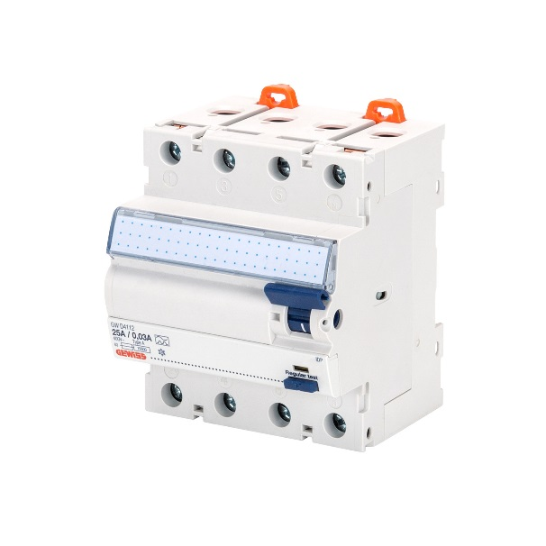
GEWISS announce the new residual current circuit breakers 90 IDP range: a wide range of solutions, suitable for both residential and heavy environment installations, that confirms GEWISS' passion and vocation for design and manufacturing high-performance circuit breakers.
IDP RCCBs are available in 2 and 4 poles, with rated currents from 25 to 125A and sensitivities from 10mA up to 500mA. In addition to the type AC, A and B, the new range includes special versions designed to avoid unwanted tripping (Impulse resistant type) and obtain selectivity between devices (Selective type). The products quality is certified and guaranteed by the most important international quality marks.
The RCCBs have been designed by paying special attention to the installation of the products. It is simple and safe to use the IDP RCCB throughout their life cycle, thanks to details such as the label holder for the indication of circuits’ name, the indication of the tripped circuit breaker, the insulated terminals with double connections for wiring with cable and busbar and the possibility to install electrical and mechanical accessories.
To ensure the service continuity in complete safety, the RCCBs could be combined with ReStart, the smart automatic reclosing device invented by GEWISS which, iIn case of an RCD trip, quickly reconnects the supply only after checking the insulation level.
90 IDP Range devices complete and integrate the GEWISS protection system: a technologically advanced solution, including standard and compact MCBs and RCBOs, RCD Add-on blocks, modular accessories, MCCBs, distribution board and quick connection system, that provides excellent electrical performance for applications up to 1.600 A.

