February 2018
SMART[PRO] 2.0: PROFESSIONAL FLOODLIGHTING FOR LARGE OUTDOOR AREAS
GEWISS presents its completely new solutions for Smart Lighting based on efficiency and energy savings.
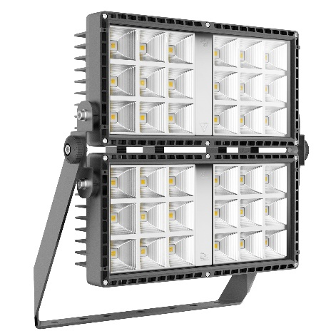
GEWISS, an international reference in the electrotechnical sector, presents a significant product innovation in the field of lighting systems: Smart[PRO] 2.0.
The technological evolution of Smart[PRO] family, the 2.0 range is patented by GEWISS, and entirely designed, developed and produced in Italy. It represents the ideal solution for large outdoor areas such as sports facilities, car parks, green areas and parks.
New Smart[PRO]2.0 lighting devices offer visual comfort, safety and exceptional lighting quality assuring safe, efficient and comfortable public areas and facilities. This range of high-power LED floodlights combines the most advanced technology on the market with simple installation, offering better lighting performance, also thanks to its 8 different optical options, and enabling great energy savings in both simple and complex systems.
Smart[PRO]2.0 floodlights can fit in several contexts, due to their compact and essential design as well as thier flexibility and modularity. They guarantee effective thermal dissipation and extremely low maintenance costs, whilst providing the right, required light output. Finally, the Italian design, together with the careful choice of components and materials, ensure reliability and stability.
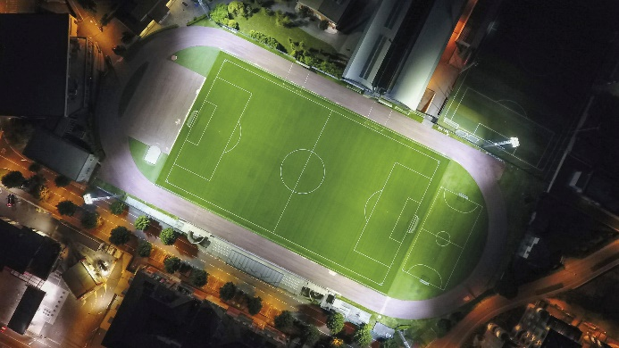
The complete range consists of one, two and four modules devices able to replace traditional sources from 250W to 400W HID, with a luminous flux up to 30.000 lm. All devices come with built-in dimmer and can be set with different drive currents in order to optimise consumption and increase energy efficiency.
The new Smart[PRO] 2.0 devices are the ideal solution for several outdoor applications (also mounted on lighting towers): in airports/hangars, road intersections, storage areas and shopping centres’ car parks, as well as for sports facilities such as stadiums, football pitches, volleyball, tennis and basketball courts.

