September 2018

ESALITE: A COMBINATION OF thought AND tECHNOLOGY
gives the ideal GEOMETRY for LED lighting

GEWISS makes the innovative range of hexagonal LED devices, designed and patented to offer top performance for every indoor or outdoor application

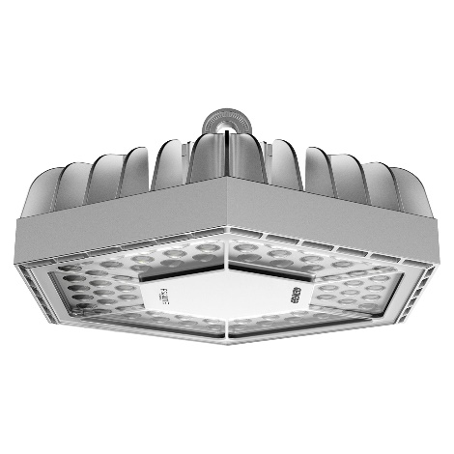
The perfection of the hexagon - a regular shape that contains other shapes - and a modular construction are what inspired GEWISS to create ESALITE, a range of LED lighting devices that offer top performance in indoor and outdoor areas. Designed, developed and produced in Italy.

With over 350 versions, with their streamlined shape and multi-use nature, lighting efficiency up to 145 lm/w, long-lasting reliability and top-of-the-range performance are what make ESALITE a major GEWISS revolution in the field of industrial lighting.

The perfect blend of engineering perfection and design, even for the most demanding applications, ESALITE is designed to be virtually indestructible and extremely long-lasting.

The range includes seven different levels of light flux, four technopolymer optics (30°, 60°, 90°, elliptical) and three LED colour temperatures (3000K, 4000K, 5700K). A DALI (Digital Addressable Lighting Interface) control system is incorporated as standard into every product, and the range includes high bays for industrial use, functional floodlights and architectural floodlights to illuminate and blend into green spaces and gardens.

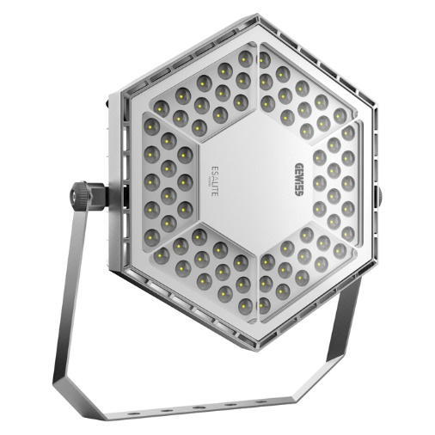
ESALITE is a unique, exclusive solution with its innovative cardan joint, patented by GEWISS, that allows the device to be moved and directed easily: a single hexagonal screw with a square, self-locking nut enables the light to swivel on two ‘Cartesian’ axes, with a toothed closure system to ensure it is completely locked in place.

The die-cast aluminium structure provides excellent lighting and makes it extremely robust and resistant to dust and moisture (IP66 degree of protection), with the IK08 tempered glass adding extra protection against shock and vandalism. The fixing ring integrated in the top of the die-cast structure of the high bay version provides very easy handling and quick fixing, even in harsh environments.

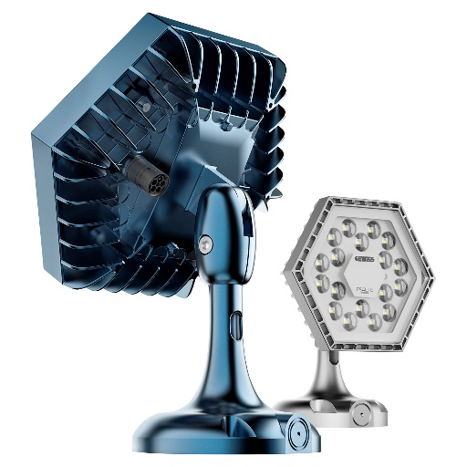
ESALITE is an exclusive range: with one version for purely industrial applications, and the 3K and 20K versions with a BlueGreen finish – a special colour which is especially designed for installation in gardens and parks, where the device blends perfectly with the shades of blue of the evening and night.

An all-Italian product which is the result of GEWISS' vision and continuous focus on the highest quality standards, ESALITE is the best smart solution for industry, parks and green spaces as it forms an intelligent system combining lighting industry solutions with the world of IOT (Internet of Things), thanks to the integration with Home & Building Automation systems, and especially the Smart Gateway. The use of both wired technologies (KNX/DALI) and wireless ones (Zigbee for industrial applications and Zigbee/Lora for use in parks and green areas) allow these devices to overcome application and installation restrictions, introducing functions and flexible solutions that can be updated over time, even at a distance – providing total control and highly efficient consumption management.

For industrial applications, thanks to integrated sensors, lighting intensity can be adjusted (to switch-off) based on the presence of people and the amount of light in the area.

Apart from standard wiring with 5-pole input, ESALITE can be supplied upon request with a second input (230V and DALI) thanks to a specific pre-arrangement on the back of the heatsink. This option makes ESALITE highly flexible, and suitable for any installation whether in relamping projects or in new installations.

