November 2016
THE EMERGENCY SYSTEM BECOMES CENTRALISED
The STARTEC NET range from GEWISS offers advanced solutions for creating centralised emergency systems.
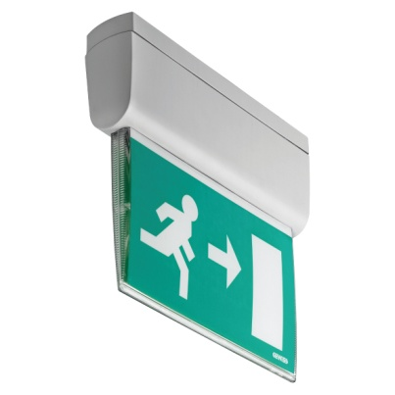
Creating centralised emergency systems is no longer a problem, thanks to the STARTEC NET range from GEWISS: a complete range of emergency autonomous luminaires able to communicate with the system control unit via the LonTalk communication protocol. Integration, expansion, modularity: these characteristics make STARTEC NET the most efficient solution for creating a centralised emergency system with the possibility of expansion and remote access.
The STARTEC NET range includes autonomous luminaires for centralised management systems in a fluorescent version or with LED technology, for surface-mounting, ceiling-mounting, double-sided use and flush-mounting. They are available with an IP40 or IP65 degree of protection, and an autonomy level of 1 or 3 hours. Control modules are also available for fluorescent lamps with a centralised power supply (UPS).
The double-sided luminaires with LED technology are offered in the conventional version and the version with an additional side spotlight that allows the integration of two functions in a single product: signalling and emergency lighting. In addition, via control unit management it is possible to set dimmer levels for the permanent status.
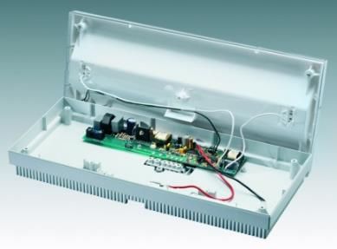
All the luminaires are equipped with a double internal microprocessor: one for managing the lamp and performing the self-diagnosis tests, and the other for managing communication with the NEMO DIN PLUS system control unit.
Each single luminaire is uniquely identified by an alphanumeric code set directly by the manufacturer and located on the data transmission microprocessor. The luminaire code is sent on the data BUS and acquired by the system supervision device in a fully automatic manner.
The STARTEC NET range also contains certain installation items for extending the functions of the luminaires. With the NEMO DIN PLUS control unit, you can manage and control all the functions of the autonomous emergency luminaires of the range. The control unit puts together the information from the rescue units and the LON lamp sensors.
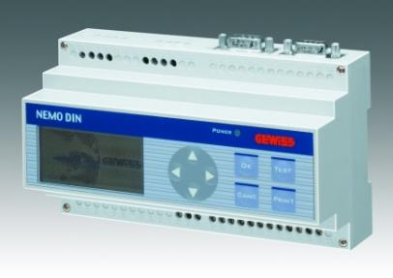
Up to 10 NEMO DIN PLUS control units can be linked together, to manage more than 2,400 emergency luminaires. The modular aspect also means you can extend the systems and activate them at different times, thereby always ensuring the safety of the building.
The GW NET software lets you manage the emergency system via an attractive and efficient graphic interface. The main functions include the import of graphic files for system map navigation, alarm visualisation, the indication of device operating status, fault diagnosis, the immediate selection of lamps requiring maintenance, and the integrated management of preventive maintenance.

