November 2016
SMART [3] - ELEGANT, EFFICIENT, VERSATILE AND SAFE
GEWISS presents Smart [3], the new watertight LED luminaires that complete the SMART range.
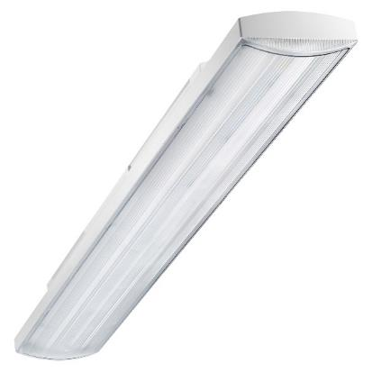
The new Smart [3] devices are a GEWISS patent. They're entirely designed, developed and produced in Italy particularly for low-height installation (below 4 metres). They are distinguished by an elegant design that highlights the particular features of the new LED technology, their extremely reduced energy consumption, their high impact resistance and their quick, easy installation. Smart [3] has been developed to become the first LED lighting solution in the world with exceptionally high protection of IP69.
The design and geometries of these new luminaires are purposely conceived for the compact dimensions of lamps using the latest technology, adding a touch of elegance and lightness in every application context. What's more, Smart [3] allows a reduction in energy consumption of up to 50% compared with a luminaire that uses a traditional lamp (T8). To save while lighting, and to light while ensuring the best visual comfort.
The opal or transparent shield with longitudinal faceting makes Smart [3] the ideal solution not only in industrial contexts but wherever the maximum attention to visual comfort is called for. The body is made entirely of polycarbonate, so the device can be installed in food-related environments too (HACCP, BRC, IFS directives). Ideal for areas with a high degree of humidity or a high concentration of dust, Smart [3] can even be installed in warehouses, storage areas, production plants, car parks, garages, outdoor canopied areas, schools and areas with traffic.
The choice of materials and the design logic of these new luminaires guarantee optimum safety during use and excellent resistance to impact, accidental knocks, water jets, humidity, foreign bodies and dust.
MAIN CHARACTERISTICS
- IP66/IP69 – IK08 – Class II. The degree of protection, earth-free insulation and high impact resistance allow Smart [3] to withstand damp, dirt and atmospheric agents.
- LIGHTWEIGHT. The extremely limited weight of the new luminaires makes all installation operations easier and smoother.
- FIXING CENTRE DISTANCE. Thanks to the wide and variable centre distance of the clips on these devices, single traditional luminaires can easily be replaced using the same fixing holes and without needing to alter the electrical system.
- THREE SIZES. The three sizes (800mm-1200mm-1600mm) ensure dimensional continuity with the traditional luminaires, allowing any lighting system to be easily regenerated.
- DOUBLE FINISH. Thanks to its longitudinal prismatic finish, the transparent shield ensures optimum lighting efficiency, while the opal shield offers excellent visual comfort.
- FEED-THROUGH WIRING. The versions with feed-through wiring offer the possibility of continuous line installation and the perfect alignment of the luminaires thanks to the specific accessory supplied as standard with the product.
- QUICK WIRING CONNECTOR. Thanks to the side opening/closing lever of the multi-pole connector, wiring and installation times (directly on the ceiling) are notably reduced.
- REDUCED THICKNESS. Compared with the market standards, Smart [3] stands out for its compactness, meaning it can be installed in places where space is particularly limited.
- 80,000-HOUR LIFESPAN AND OPERATING TEMPERATURE. Smart [3] guarantees an operating lifespan of at least 80,000h in standard conditions (-25°+40°).
- COLOUR TEMPERATURE AND CHROMATIC YIELD. The chromatic yield index of at least 80, and the 4000°K colour temperature, ensure the best lighting even in production contexts (as specified by UNI EN 12464-1).
- 45° FIXING. Using the surface-mounting fixing accessories, the luminaires can be installed with a 30° or 50° tilt.

