November 2016
CAPTIVATING LIGHT FORMS
The LED-based architectural floodlights of GEWISS's Saturno family are the stars of outdoor lighting in the most prestigious hotel of Europe.
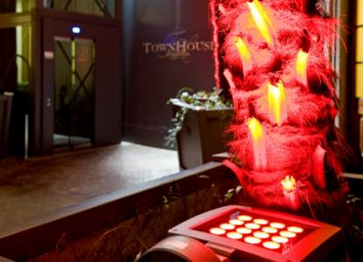
Seven Stars Galleria, the only 7-star hotel in Europe, chooses GEWISS once again. It's the lighting solutions of GEWISS's Saturno LED RGB range that are creating the welcoming atmosphere for guests at this prestigious hotel. These GEWISS floodlights use the most advanced LED technologies to combine reliability with energy savings, allowing the hotel management to create light beams, produce spectacular lighting effects, illuminate buildings of important historical and artistic value, and emphasise architectural and natural details. What's more, the DMX technology permits the definition of dynamic colour scenes (tones, intensity, transitions, etc.), thanks to an easily adjusted controller that can be integrated in the domestic system.
SATURNO LED: characteristics and advantages
The SATURNO architectural floodlights in die-cast aluminium are distinguished by their small size and innovative design, that makes them suitable for installation in prestigious architectural contexts. Ideal for emphasising architectural details (indoors and outdoors) and for creating spectacular effects with the clever use of colour too, the SATURNO floodlights are available with different optics (symmetrical, asymmetrical, circular, street) and light sources (discharge, fluorescent, single-colour LED or RGB).
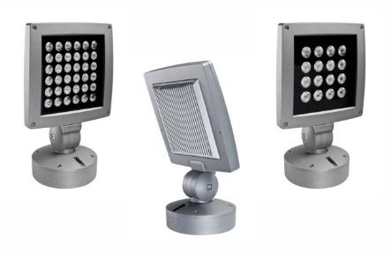
The combination of materials (die-cast aluminium) and technologies used ensures the maximum reliability of the product and a longer lifespan. The choice of lamp, the design of the product, and the devices for dynamic temperature control offer an optimum light flux and constant light emission.
The product electronics permit various levels of complexity: from basic stand-alone management to a form of management with a push-button for the scenes, culminating in the most advanced form - programming with a DMX control unit.
The DMX control unit, with LED display and icon navigation, requires a 12V AC power supply. It can command up to 20 LED RGB devices via the DMX protocol. In the case of white light, DMX management lets you choose different levels of light intensity and transitions for each single floodlight.
Equipped with a pointer that defines the degrees of tilt, the floodlights can be freely orientated on their two axes thanks to the sturdy central joint and effective locking system.

