November 2016
NEW PUBLIC LIGHTING SYSTEMS
GEWISS presents the new [O₃] range: street and urban lighting systems that combine design and technology.
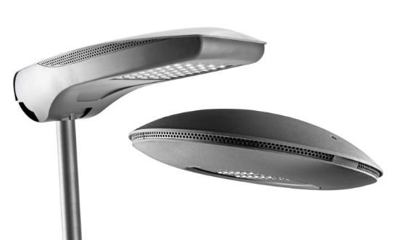
Modern urban lighting is characterised by a fragmentation of lighting solutions that are closely connected to the application context of reference. Applied experience teaches that there is no one single ideal configuration for all applications and needs can be very different, from both a technical and economic perspective. At the same time, the evolution of lighting products from electromechanical to electronic technologies can make the rigidity of the decisions made today potentially costly for tomorrow.
In this perspective, GEWISS has developed a range of products that start with the best technologies today and follow their evolution, while also maintaining the ability to move on to the one that appears to be the best over time. This freedom of selection keeps the product design unchanged and can be implemented by simply replacing the light assembly.
Urban [O₃] is a device with a pure form that is simple to combine with different types of supports. Low pole, pole head/side bracket and suspension: Urban [O₃] meets any installation configuration, providing maximum freedom and application versatility.
The new device is available in a LED configuration with 2 to 4 modules, or in the CosmoPolis version. All models offer a IP 66 degree of protection, belong to insulation class II and can house remote control devices. Versions with two-speed self-learning device and DALI versions are also available.
Furthermore, to meet the specific requirements of installers and maintenance technicians, Urban [O₃] was developed to guarantee ease of installation. The presence of a removable ball joint, which permits mechanical connection and electrical wiring operations on a "light" element, makes device installation operations very easy.
Street [O₃] is a street lighting device that guarantees lighting installations that maximise installation efficiency for any type of street, in full compliance with industry regulations and with the lowest operating costs.
Street [O₃] is available in a LED configuration with 2 (₃2 LED) to 5 (80 LED) modules, or in the CosmoPolis version. All models offer a IP 66 degree of protection, belong to insulation class II and can house remote control devices. Versions with two-speed self-learning device and DALI versions are also available.
The Street[O₃] products can be installed on all pole systems, with or without a side bracket, with a diameter from 42 to 76mm. A range of GEWISS poles and side brackets is also available with a design coordinated to the Street [O₃] devices, in order to maximise the design and characterise the final installation result.
In addition, the Street [O₃] range is completed with the new Street [O₃] Maxi, now able to meet the lighting requisites of busy main and extra-urban roads and, more generally, all open spaces where good lighting is required. It's suitable for use in warm environments with high temperatures, and is immune to induced overvoltages higher than 6kV (in accordance with CEI EN 6100-4-5 - third party certification).
The products in the [O₃] Range adopt a solution patented by GEWISS in order to solve the problem of electronic components crashing due to overvoltages caused by indirect atmospheric discharges in common mode or residual current mode: the metal parts are mechanically isolated by technopolymer elements from those sensitive to voltage peaks (typically LEDs and electronic power supplies). This immunity does not require other components to be used (e.g. SPD) that increase the product cost, require maintenance and increase the complexity of the system if it is in class II, which is very common in Italy. The immunity value according to CEI-EN 61000-4-5 is ≥6kV in common mode and ≥4kV in residual current mode.
The device characteristics also guarantee the maintenance of ideal thermal conditions through the dissipation systems directly in contact with parts that develop heat, assisted by additional side ventilation. The combination of the two solutions provides an optimal exchange between the inside and the outside, guaranteeing an excellent working life: B10L80≥24,000h for Cosmopolis systems and B10L80≥70,000h for LED systems. The B10L80 condition refers to maintaining at least 80% of the initial flow with a percentage of sources that do not respect the target of ≤10%.

