November 2016
THE LIGHT OF INNOVATION
Metrolight is the new GEWISS family of modular flush-mounting devices that use LED technology.
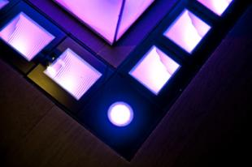
Metrolight is the LED lighting system with wallwasher optic, made up of modules that can be combined to distribute the light evenly along any indoor or outdoor path. Designed to be used in harmony in every context (pedestrian areas, walls, entrance perimeters, spectacular effects), Metrolight is implemented in glass and aluminium in order to combine technology with elegance. The use of the innovative 230V LED source (without the need for power supplies) makes it possible for designers to go beyond the limits imposed by traditional systems in terms of length, form and the number of sources that can be powered.
The modularity of the lighting elements ensures the even, efficient lighting of any size and shape of surface, without restrictions on length, direction or light plays, even after product installation.
The lighting effect will seem continuous and uniform, even between one module and the next, however many modules have been installed.
The light source, product design, connection system and outer casing make installation quick and easy. Due to the use of LED technology, Metrolight makes it possible to creating lighting independently of the dimensions of the products or the light sources.
The device is available in versions with serigraphed glass, in black or white.

