November 2016
ONE PRODUCT, A THOUSAND SOLUTIONS
A new range of aluminium floodlights, MERCURIO 2, has been created by GEWISS to meet all urban lighting requirements.
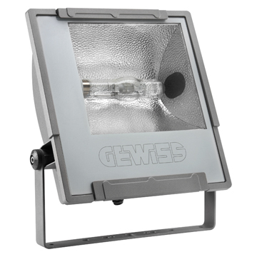
Mercurio 2 is a range of low and medium power (up to 400W) outdoor floodlights in die-cast aluminium designed for urban, industrial, sports and street lighting. The quality of Mercurio 2, the wide range of optics, and the choice of high efficiency light sources, are factors that ensure excellent lighting performance and reduced consumption. What's more, the photometric performance levels allow you to create applications with notable energy savings.
Attention is paid to every detail of the Mercurio 2 floodlights, combining functional aspects with the most refined design requirements. The opening/closing handle system, which is used without other tools, and the vandal-proof lock system permit simplified installation and maintenance.
Mercurio 2 is available with symmetrical, asymmetrical, circular and street optics, offering various design solutions. All safety, control or light shielding accessories are snap-coupled without the use of any tools. The elegance, compactness and wide availability of accessories make the Mercurio system suited for pole installations for street or public area urban lighting solutions.
The selection to use feed-through wiring between the floodlights as a standard ensures the fast and easy installation of the product. Furthermore, the system for fixing the bracket, with a graduated scale goniometer, makes it possible to easily obtain and maintain directions according to design parameters, maximising the lighting potential of the product.
Due to its asymmetry, Mercurio 2 is ideal for installations with the glass parallel to the ground, in full compliance with current light pollution laws.

