November 2016
LIGHT HARMONY
GEWISS presents the new LED lighting devices of the Luxor Range.
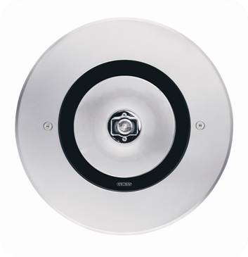
Luxor, Luxor Wall and Luxor Wallwasher are ideal solutions for fully meeting the lighting requirements of the residential building industry (green areas, communal areas, condominiums and villas). Luxor devices are designed to compensate for any installation or maintenance problems: in addition to guaranteeing an IP68 degree of protection, the quality of the materials and design logic ensure resistance to conditions of outdoor use.
The family consists of floor flush-mounting devices, wall flush-mounting devices (Luxor wall) and the wallwasher range.
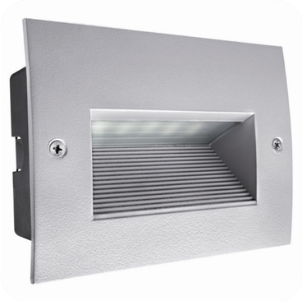
LUXOR GROUND. The use of materials with high mechanical characteristics guarantees the drive-over capacity of the devices without compromising their compactness. The closure flange can be easily aligned independently of how the outer casing was installed. The isolation of the cable input and the corresponding resin finish prevents moisture from entering the device (IP68 degree of protection). Available in a wide range of sources and light distribution effects, the Luxor ground family includes versions with a steel or aluminium finish and with a rectangular, square or circular flange.
LUXOR WALL. The Luxor shapes maintain the unmistakable style of the Chorus LUX domestic range, which reflects the plate design in the closure flange. The product is fixed to the outer casing with only two screws, which makes the correct closure of the product independent from the correct installation of the outer casing. Luxor Wall is available in four different sizes and with multiple light sources (also Led) with symmetric and asymmetric light distribution.
LUXOR WALLWASHER. This product can be adjusted up to 15° (with 5° steps), ensuring maximum flexibility of use in every application. The compact dimensions make it possible to use the device in situations that require minimum overall dimensions and an excellent result. Available in two lengths depending on the source used (LED or fluorescent) and on the power level.

