November 2016

ONE DESIGN, A MULTITUDE OF FUNCTIONS

The DEDALO family of architectural floodlights is extended with new LED versions.

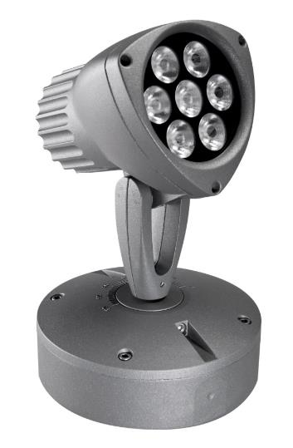The DEDALO architectural floodlights are designed to emphasise architectural and natural details, illuminate parts of advertising signs, and create light beams and spectacular effects (with colour too).

The floodlights can be equipped with various light sources: apart from the version with a 2-plug halogen lamp (max. 75W or B15d max. 100W), the DEDALO devices are also available with a metal halides lamp (max. 70W) or with single-colour high-power LEDs (7x1W) and Full Color RGB LEDs (7x3W) to meet all design needs yet still ensure energy savings and an excellent lifespan.

The choice of lamp, the design of the product, and the devices for dynamic temperature control offer an optimum light flux and constant light emission. The product electronics permit various levels of complexity, from basic stand-alone management to a form of management with a push-button for the scenes, culminating in the most advanced form - programming with a DMX control unit.

The floodlights can be freely orientated on their two axes, and are equipped with a pointer that defines the degrees of tilt. In the case of white light, DMX management lets you choose different levels of light intensity and transitions for each single floodlight. The colour management control unit has a LED display with icon navigation, and can command up to 20 LED RGB Dedalo or Saturno devices via the DMX protocol.

The mixing of the three primary colours at source produces saturated colours and sharp transitions; every lens has three LEDs to adopt the pre-chosen colour. The RGB Full Color version has an electronic unit built into the base, allowing the LED colours to be altered cyclically by means of an external push-button or DMX control unit.