November 2016
THE ELEGANCE OF LIGHT
Bilight and Trilight are GEWISS devices for LED lighting of outdoor areas.
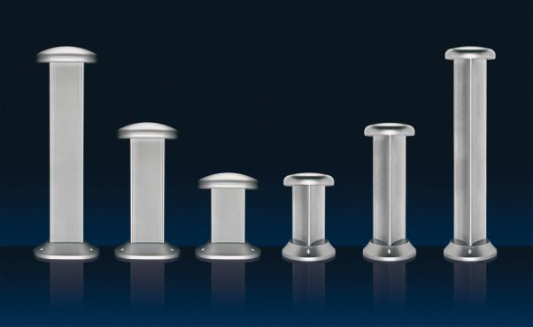
Bilight and Trilight are GEWISS devices created for the outdoor lighting of residential buildings (condominiums and villas) and green areas (parks, gardens, footpaths, communal areas, etc.). Made with die-cast aluminium, the new devices adopt LED technology, which reduces energy consumption and guarantees a longer life cycle than traditional sources. The devices have a system of dual ignition: one for the main lighting and another for signalling.
BILIGHT is characterised by its rectangular section with 4 white LEDs for ordinary lighting and 2 LEDs (white, blue or amber) for light signalling. The light distribution created by BILIGHT produces spectacular plays of colour and shadows, while the geometries of the stem and base create interesting light effects. The rounded forms of the BILIGHT body help water to run off when it rains; the drip-guard edge on the diffuser prevents water from collecting.
TRILIGHT transforms outdoor areas into extraordinary scenes where light becomes an important design element. Thanks to their compact, innovative design, they are ideal in all those contexts requiring diversified lighting management, whereas, the treatment and materials that are used guarantee optimum resistance to external agents. TRILIGHT has a triangular section with 6 white LEDs for ordinary lighting and 3 LEDs (white, blue or amber) for light signalling.

