November 2016
ASTRID LED: COMFORT AND SUSTAINABILITY
GEWISS presents the new ASTRID family of flush-mounting LED systems for the commercial sector.
With its new ASTRID range of LED flush-mounting lighting systems for the commercial sector, GEWISS proposes new solutions for the latest requirements of the lighting industry. The new items of the ASTRID range are designed to offer more comfort and sustainability in the working environment, giving it a pleasant and elegant feel.
A COMPLETE FAMILY FOR EVERY NEED
ASTRID LED is the innovative line of professional flush-mounting devices with LED technology designed for different application areas such as offices, hotels, reception facilities, and all areas of the commercial sector in general. A range able to guarantee high levels of lighting performance, excellent energy savings, and good visual comfort.
The range includes:
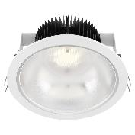
- ASTRID ROUND
Circular LED flush-mounting elements
Circular flush-mounting downlighters, available with two different types of optic: with a wide beam (for diffused, even lighting) or a narrow beam (for more specific, accentuated lighting).
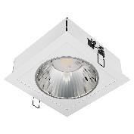
- ASTRID SQUARE
Square LED flush-mounting elements
Square flush-mounting downlighters, available with two different types of optic and with two different colour temperatures (3000 and 4000 K). The DALI version can be ordered, for light flow regulation.
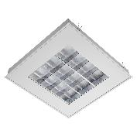
- ASTRID 60x60
Modular LED flush-mounting elements
Modular flush-mounting devices, 60x60cm, available with three different types of optic: diffused (for soft, extensive lighting), prismatic, and dark light (both ideal for installation in offices and conference rooms, even where video terminals are used).
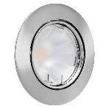
- ASTRID 75
Low energy LED flush-mounting downlighters
Low energy flush-mounting devices with a 10W (1000 lm) LED lamp. In all the versions, the finish ring in die-cast aluminium can be adjusted to facilitate the pointing of the light beam, and is available in either glossy white, metallised aluminium, gold or bronze.
The ASTRID LED flush-mounting downlighters can guarantee energy savings of more than 50% compared with conventional solutions using T8 electronic fluorescent lamps. This means that companies and reception facilities can considerably reduce their costs: in fact, at least 40% of energy consumption can be attributed to lighting, and over 70% of existing installations are based on obsolete, inefficient technologies.
LED TECHNOLOGY
The success of LED technology in functional lighting has been the most important lighting industry revolution of the past decade. Thanks to rapid improvements in LED performance, solutions can now be created for interiors and exteriors featuring an outstanding light efficiency, considerably energy savings as well as dynamic lighting that can adapt to a whole host of applications.
Using LED devices indoors - especially in offices - provides numerous advantages. From the aesthetic viewpoint, a non-invasive light that's as natural as possible can have a positive impact on the mood and health of workers. In economic terms, the use of LED technology ensures notable energy savings thanks to the low consumption, long lifespan, reduced maintenance and stronger performance compared with a conventional lighting system. It's no surprise then, that LEDs are becoming increasingly popular for the commercial sector.

