November 2016
COMFORT WITHOUT WIRES
The GEWISS devices for wireless control let you extend the functions of the domestic system without any need for masonry work.
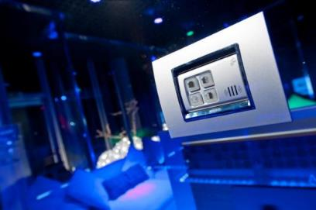
The home changes over time, renewing itself and improving, and the electrical system changes with it. The flexibility offered by wireless technology means you can install commands and burglar alarm devices on structures unsuitable for containing wires: if you decide to change the furnishings, you won't have to damage the walls in order to reposition the socket-outlets and plates because, thanks to the RF command and control system, this is no longer a problem. The wireless communication devices let you extend the functions of the conventional electrical system, but without any need for masonry work.
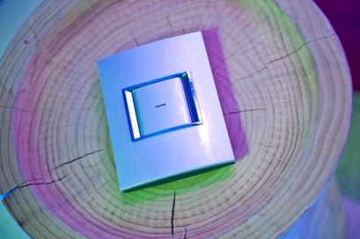
The RF push-buttons can be installed everywhere, using double-sided sticky tape. The push-button panels make the home more versatile, leaving you free to create new furnishings and alter the layout of the furniture whenever you want. Thanks to the wireless devices, you can activate the burglar alarm, raise the roller shutters, switch on the lights, etc. with the aid of a sort of remote control that you can take from one room to another, deciding not to fix it to any particular wall.
The RF Command and Control range of devices is especially suitable in the following environments:
- systems to be restructured, where supplementary functions need to be added;
- systems yet to be created in prestigious contexts with architectural limitations;
- new systems where the furnishing solutions often require a specific electrical intervention.
Easy installation and programming
The design of the push-button panels blends with any existing electrical system. The actuators are designed to be assembled in both System supports and junction boxes. The wireless system offers exclusive technical solutions for environments awaiting renovation, minimising the invasive nature of the system.
Total system integration
Various functions can be managed with the wireless devices.
- Manual commands: management of commands free from the mains supply.
- Input management: management of potential-free generic contact inputs.
- Electric loads: direct or timed ON/OFF commands.
- Roller shutters: up/down motor command.
- Temperature adjustment: management of weekly temperature profiles for heating/cooling systems.
There is no need to purchase programming software in order to configure any devices or link them to one another - all you need to do is manually set them.
Versatile actuators/receivers
The actuator/receiver devices are multifunctional: for the generic actuators, you can select one of the configurations (monostable, bistable and timed); for the motor command actuator, you can select one of the pre-set timings.
Reliability and safety
The devices exchange information using low power wireless frequencies and only for very brief transmission periods, hence saving battery energy and occupying the frequency band for a very limited time. A blinking LED indicates the battery's charge status and wireless signal transmission.

