November 2017
THE PERFECT TEMPERATURE IN A SINGLE TOUCH
With the new Thermo ICE devices by GEWISS, a single touch is all you need to manage your heating/cooling system.
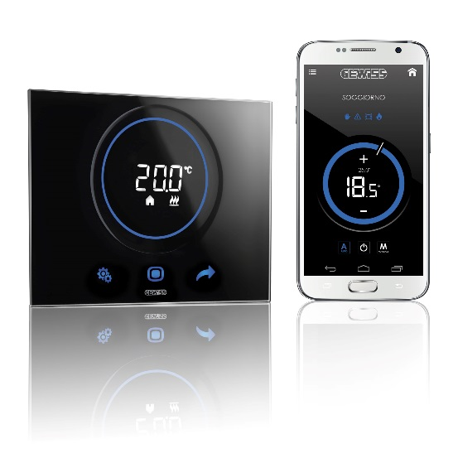
Chorus, the international domotics system by GEWISS that offers state-of-the-art solutions for management, control and safety within the home, is further enriched by a new range of thermoregulation devices for the residential and commercial sectors: Thermo ICE.
The new thermostats enable you to intelligently control the temperature of your home. At any time of day and during any season, you can set the climate control systems to just the right temperature, preventing any unnecessary waste of energy.
Thermo ICE is made from a full-glass plate, available in white, black and titanium colours, with touch controls, RGB circular touch slider and white LED rear projection display. With a nod to modernity and technology, the sophisticated, refined design of this solution won Thermo ICE the prestigious IF Design 2016 prize in the Building Automation category.
In addition, the new thermostats have been designed to meet all installation requirements, with a particular focus on flexibility: flush-mounting can be used for both the round/square or rectangular boxes.
The Thermo ICE range includes two versions, which are capable of meeting all requirements:
- Thermo ICE KNX is the solution for domotics systems that uses the KNX protocol, the European standard for data transmission and management in buildings automation applications. This device enables the management of heating/cooling functions in both 2 and 4-way systems, using two-point, proportional-integral and fan-coil control algorithms. When combined with an external humidity sensor, it can also be used to manage a humidification/dehumidification system. This solution is equipped with an integrated temperature and proximity sensor, as well as two inputs for potential-free contacts (e.g.: window contact, NTC external temperature sensor, etc.). Thermo ICE KNX is configurable both in KNX-System and KNX-Easy mode.
- Thermo ICE Wi-Fi is the all-in-one solution for those who want to manage the temperature of their home remotely. Thermo ICE Wi-Fi combines the features of Thermo ICE with a number of advanced remote features. With an exclusive app for smartphones, available for iOS and Android systems, Thermo ICE Wi-Fi can easily be controlled remotely, increasing its functionality from a simple thermostat to a timed thermostat. The app can be used to control the thermostat and display its operation status, as well as to programme the timings of the various weekly heating profiles, either manually or via the self-learning function. Using the latter, the device spends a week learning the user settings, and at the end of this period, the profile created on the basis of this is automatically made available. Furthermore, as of now, the new version of the app for smart watches is also available, for use with both Apple Watch and the Samsung Gear S2. Via the digital clock, users can control many of the features of Thermo ICE: managing the different temperature set points, changing the status of the thermostat (on/off or pre-set scenarios such as summer, comfort, pre-comfort) and displaying the temperature of the various connected devices. Both versions of the Thermo ICE app (for smartphones/tablets and smart watches) use a cloud connection to communicate with each other and with the thermostat.
Comfort, energy savings, remote control and design: With the new Thermo ICE solutions, your home becomes more intelligent, improving your comfort every day. And all this without forgetting the elegance of the shapes and colours: the design of these devices features refined lines and an avant-garde spirit, blending perfectly with the style of the Chorus ICE touch plates, where modern flair coexists in perfect harmony with the elegance of tradition.

