November 2016
SMART RESOURCE CONSUMPTION
Chorus encourages a more rational use of water for watering the garden, and of electricity for outdoor lighting.
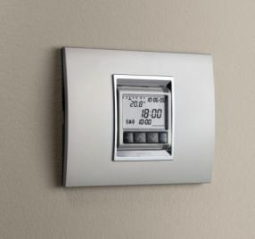
Amongst the many advantages of the GEWISS Chorus domotic system, apart from reduced energy consumption, there is undoubtedly the rationalisation of an essential natural resource: water. Irrigation is very important for the health of our plants and for keeping our gardens green. We often use too much water though, not only causing damage to vegetation but also increasing our water bill.
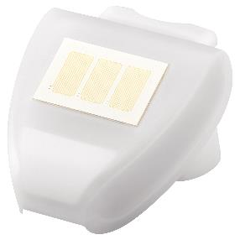
The Chorus system autonomously manages even the most sophisticated irrigation systems: when connected to the domotic system, just a few simple operations are needed to automatically implement the watering of the garden via the timer that can be installed in the domotic system plates.
What's more, by using the GEWISS weather station to detect temperature, rain, outdoor light intensity and wind speed, you can avoid water consumption when rain is forecast, and activate the outdoor lights on the basis of the real lighting conditions.

