November 2016
DOMOTICS BY GEWISS, THE HOME IS SAFER
GEWISS presents the devices of the Chorus domotic system, that guarantee the safety of people in the home.
THE CHORUS DOMOTICS SYSTEM is compatible with international standards and offers solutions for various residential needs. Thanks to a model in which every component is separate but dialogues and is integrated through its interaction with the others, CHORUS guarantees an infinite number of combinations that can be used to suit every individual need, ensuring that the system can be expanded and new functionalities can be introduced at any moment.
"Safety" doesn't just mean protection against potential dangers from outside, but also against those that may result from faults or anomalies in the systems themselves.
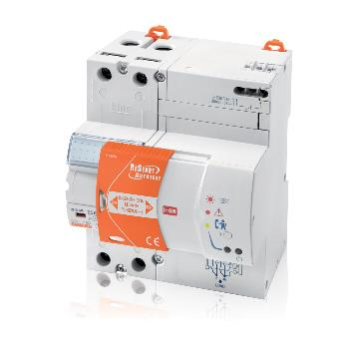
In the event of a storm and/or voltage surges that cause a blackout and expose the home to the consequential risks, GEWISS offers ReStart with Autotest. Everyone's had the experience, at least once in their lives, of being at home and having to go and reactivate the electricity supply after a sudden power failure; or of coming home and finding the freezer defrosted; or finding the heating system, irrigation system and burglar alarm deactivated.
The culprit is often not a system fault but lightning or a voltage surge that triggers the “residual current device” - the electric device installed in the enclosure that protects us against the risk of electrocution in the case of accidental contact with the electricity supply. The reactivation of the residual current device is a simple - but usually manual - operation. In the event of prolonged absence, or houses with no surveillance (such as a holiday home in the mountains or by the sea), the untimely intervention of the residual current device can cause long periods with no energy supply, and therefore serious, unforeseeable damage.
To resolve this problem once and for all, GEWISS has created RESTART with AUTOTEST: when there is a power failure due to a voltage surge or a storm, this simple electric device (that can be installed in any enclosure) resets the energy supply automatically in just 10 seconds, but only after checking there is no danger for the user. If, on the other hand, the triggering was caused by a permanent fault (such as a short-circuit or a bare wire), RESTART impedes the reset and indicates the problem by means of an indicator lamp.
Furthermore, the innovative GEWISS device is the only one able to guarantee residual current protection over time, as it automatically carries out a complete test every week, triggering the circuit breaker relay, without disconnecting the power from the system. For traditional residual current circuit breakers, this test must be done manually using the "T" button key and requires disconnecting the power from the system. This then makes it necessary to reprogram the alarm clocks, video-recorders, microwaves, alarms, fax machines, answering machines, etc.
REMOTE CONTROL OF THE HOME
In addition, the Chorus domotic system lets you control and command all the system devices from a distance. As well as receiving alarm text messages if there is any danger in the home, you can also remotely command the devices connected to the system; all it takes is a personal computer, tablet or smartphone connected to the Internet and you can manage all the domestic functions even when you're not there.
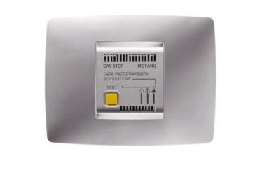
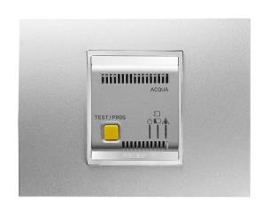
GAS AND WATER DETECTORS
Thanks to specific sensors, the GEWISS devices quickly detect gas leaks, floods and the beginnings of any fires - events signalled even when there is nobody in the house. If there are anomalies, the GEWISS gas leak and flood detectors demonstrate the ability of the domotic home to manage unforeseen events and ensure increasingly high safety standards.
The gas detectors check for the presence of dangerous substances (methane/LPG) in the household environment and, in the event of an alarm, enable the activation of a solenoid valve via an output contact. Provided with optical and acoustic alarm signalling, remote access of the SMS signal is possible.
The water detector verifies the presence of water or other liquids by means of one or more sensors (wireless connection) and, in the event of an alarm, it enables the activation of a solenoid valve via an output contact. With buzzer and optic warning signal. Also suitable for remote access.

