November 2016
THE CHORUS HOME IS A SAFE HOME
In the event of a water or gas leak, the Chorus devices warn the user of the danger and intervene to make sure the home is safe.
"Safety" doesn't just mean protection against potential dangers from outside, but also against those that may result from faults or anomalies in the systems themselves. Thanks to specific sensors, the GEWISS devices quickly detect gas leaks, floods and the beginnings of any fires - events signalled even when there is nobody in the house. If there are anomalies, the GEWISS gas leak and flood detectors demonstrate the ability of the domotic home to manage unforeseen events and ensure increasingly high safety standards.
Every tiny leakage of water or gas due to distraction or system faults is detected and signalled by the sensor. In the case of sudden weather variations that could cause damage to awnings, outdoor anti-glare louvres or door/window frames, the wind sensor detects such changes and automatically closes skylights, roller shutters and awnings.
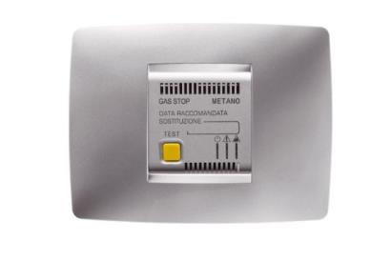
GAS DETECTOR
The gas detectors check for the presence of dangerous substances (methane/LPG) in the household environment and, in the event of an alarm, enable the activation of a solenoid valve via an output contact. They provide optical and acoustic alarm signalling, and remote signal access is possible via text messages.
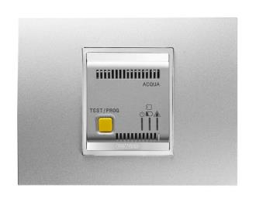
WATER DETECTOR WITH RF SENSOR
The water detector verifies the presence of water or other liquids by means of one or more sensors (wireless connection) and, in the event of an alarm, it enables the activation of a solenoid valve via an output contact. With buzzer and optic warning signal. Also suitable for remote access.

