November 2016
WITH CHORUS, THE HOME NO LONGER HAS ANY LIMITS
The CHORUS domotic system from GEWISS offers cutting-edge solutions for the management and control of homes and buildings, even from a distance.
In 1955 Eugene Polley invented the first remote control for television, paving the way to a dream that, in the following years, would have captured the imagination of many people: to control everything around them with just one finger. Today, thanks to the Internet, mobile technology andtouchscreen devices, this dream came true.
From the screens of smartphones and tablets, in fact, is possible to manage and control an
increasing number of devices: computers, appliances, lighting systems, cameras, sound systems... And even more. The integration with home automation made possible the control and management of your own home by mobile device, wherever you are, redefining the limits of contemporary living. Home living, today, does not just apply to the time in which you are physically in the home. Because your home is with you wherever you are.
GEWISS offers two solutions for the control and management of the house both locally, via the home WiFi network, as well as remotely via an Internet connection: HAPPYHOME and Master ICE.
HAPPYHOME. And your house becomes Easy.
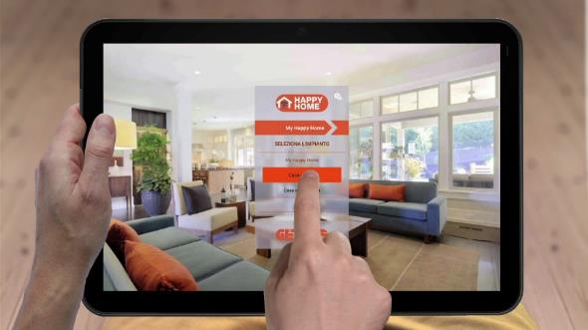
HAPPY HOME is the new APP for local and remote management of the KNX and KNX Easy systems that allows you to control and display, in a simple and intuitive manner, the lighting, roller shutters, venetian blinds, configure and execute scenarios, adjust the temperature and humidity of each room, monitor energy consumption and manage the burglar alarm. HAPPY HOME is developed for Android and iOS smartphones and tablets and is available for free. The APP can be used with any KNX installation equipped with GEWISS' KNX/IP interface. For that reason HAPPYHOME is the cheapest solution on the market to control and manage the home automation system from mobile devices, fully exploiting the comfort potential of a highly evolved home system.
MASTER ICE. Your home always under control.
MASTER ICE is the new, beating heart of the modern home, the hub of all the system devices for governing the domestic environment. With the Master ICE touchscreen panel you can command your home from a distance: lighting devices, roller shutters, air-conditioning system, irrigation systems, alarm devices, video entryphone and video control could be controlled directly from your smartphone. So the entire home is constantly under control, even when you're not there. For that reason, Master ICE is the ideal solution to secure the safety of second homes (whether they are by the sea or in the mountains) and also to go on vacation without worries.

