June 2017
THE FORMS OF BEAUTY
ONE, GEO, LUX, FLAT, ART and ICE are the plates used for the international Chorus domotics system from GEWISS: six different forms that are able to reflect the character, personality and style of those who live in the home. All based on the spontaneity of gestures and the simplicity of a command.
New materials and state-of-the-art technologies produce conditions of equilibrium and harmony, allowing the creation of unique environments that can meet even the most complex needs: ancient and modern are mixed together seamlessly, rustic charm can co-exist with high-tech and refinement is fused with a minimalistic style.
This reflects the liberty with which different epochs and styles are combined, a contamination in which the signs and symbols of modernity and tradition are revisited in order to generate new meanings, reflecting the objects of daily life. Details such as push-buttons are more frequently becoming a point of focus for the walls of our homes: designed to perform the simple task of turning lights on and off, previously a push-button did not have any aesthetic pretence. In fact its presence on the wall should not have even been noticed.
Symbol of the domestic metamorphosis, today a push-button is appreciated and offered in different colours and materials and, at the same time, accomplishes all the most important functions for the home. For this reason, it can be considered a paradigm of the new way to conceive a home, because it is able to integrate form and content in a single solution; if it is true that a home can be decorated according to your own personal style, it is also just as true that with a very simple gesture you can decide about how much light there should be in the various rooms, set the temperature and activate roller shutters or awnings during the different moments of the day.
GEWISS has expanded its new push-buttons, implementing the Chorus domotics system line with a wide range of materials, shapes and finishes. A perfect mosaic of technology, elegance and performance to satisfy every taste and requirement, regardless of the configuration that is chosen and installed.
The design of all the elements of the Chorus domotic system is co-ordinated with the six very special shapes of the One, Geo, Lux, Art, Flat and Ice plates.
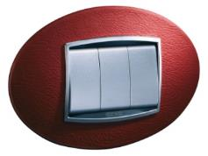 | ART. Futuristic design, innovative materials. An extremely original and creative line of plates, with an oval form, which in itself can furnish and decorate every room. Available in metallic painted technopolymer, or in the exclusive versions in natural materials: wood, leather, glass and stone.
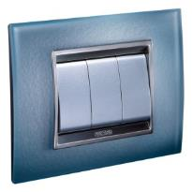 | LUX. Refined lines, high-tech spirit. A line of plates with a contemporary form, where a modern spirit lives in perfect symbiosis with a personality that loves the elegance of tradition. A touch of class with every touch. LUX in technopolymer, metal, glass, wood and leather offers a solution for every style.
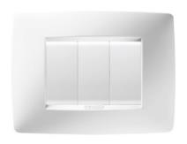 | ONE. Resistant materials, classic forms. A line of plates that has an understated simplicity and a classic air that makes the most of every environment, adding a touch of harmony and beauty to all walls of your home. Available in the technopolymer version
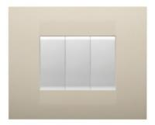 | GEO. With simple and light colours and shapes, GEO is a line of youthful and informal plates that conveys a minimalist feel in every room. Made of top quality technopolymer, GEO resists both sudden shocks and everyday strain.
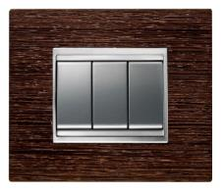 | FLAT. With its larger dimensions, Flat is a line of plates for large spaces and becomes a real decorative element in large buildings, modern homes, villas, attics, lofts, open-space areas, etc. Glass, wood, and metal: authentic and refined materials used to establish continuity between the push-buttons and the design solutions in every room.
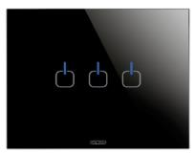 | ICE. With the Chorus ICE glass plates, luxury meets technology. In addition to the traditional commands, the ICE plates are also available in a Touch version: simply touch the surface of the plate to control the lights or roller shutters or to set a predefined domotic scene.
A UNIQUE STYLE FOR EVERYONE: MATERIALS AND COLOURS
Chorus offers various materials to add harmony and colour to the walls of your home.
Glass. The purity, the intensity of the colours and the brilliance of the reflections make glass the perfect material for plates that want to be striking, original and yet elegant.
Leather. An amazing quality that asks to be touched, day after day, and that brings the inhabitants' elegant lifestyle into every room.
Wood. The grain, the shades of colour, the scent, the vitality, the warmth. All the remarkable qualities of wood live in the details and design of the Chorus system plates, lighting up every room with a unique personality.
Metal. The solidity of the aluminium is transformed into a lightness; the strength of the oxidised iron becomes beauty; the glamour of the steel becomes light, and your home reflects your style.
Technostone. A natural element that adds a solid feel to the most traditional styles.
Technopolymer. Safety and practicality are the two outstanding features of the technopolymer plates.
You can also select the colour tones and schemes that are best suited to every room. For example, you can select a cherry Chorus Lux plate to match the furnishings; in the living room you can add a touch of elegance with a white glass Flat plate; or, you can select the original geometry of Art in leather for the bedroom, in white, ruby and black.
PUSH-BUTTONS AND SWITCHES: SPACE WITHIN REACH
To optimise the space and improve the system design and practicality, you can use the Chorus modular devices. Compared with traditional solutions, the possibility to combine keys of ½, 1, 2 and 3 modules allows you to rationalise the number of push-buttons.
The 2- and 3-module devices are easy to use and ensure the quick localisation of the push-button, while the ½ module (only available with Chorus) makes the best use of reduced spaces.
You can even choose the colour of the keys, matching them to the plates: glossy white and backlit - versatile, and doesn't get dusty; satin black - modern and elegant; painted titanium - refined and exclusive.
CHORUS offers a wide range of socket-outlets too: double and triple dual amperage, both single standard and double standard. A wide range of devices completes the choice of push-buttons: presence detectors for the automatic switch-on of lights, anti black-out lamps, leak detectors, TV and SAT socket-outlets, climate control, telephone/audio/video connectors, and network cabling.

