November 2016
NAXOS: QUALITY AND ELEGANCE AT THE HIGHEST LEVEL
GEWISS presents the new devices of the Naxos range: refined, modern lines for the video entryphone and domotics supervision.
Naxos is the new GEWISS family of devices for video entryphones and domotics surveillance, where quality, elegance and technology come together in the best possible way.
The devices of the Naxos range stand out for their design, that blends elegance with the hi-tech spirit of contemporaneity; the innovative geometries are designed, in fact, to produce a refined, understated style that accentuates both the architecture of the building and the design of the furnishing elements inside the home.
The result is a wide range of user-friendly items displaying a high level of design and technological innovation.
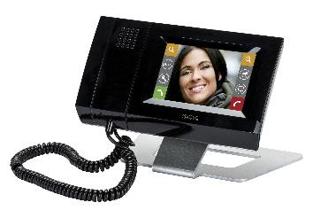
Naxos – The video entryphone solution
Naxos is the video entryphone with a 4.3” LCD colour touchscreen display with integrated speakerphone audio and handset. It guarantees excellent audio and video management and offers fast, intuitive navigation through the customisation menus. Naxos can be surface-mounted or free-standing (with the appropriate accessory) in any residential context, regardless of the number of homes.
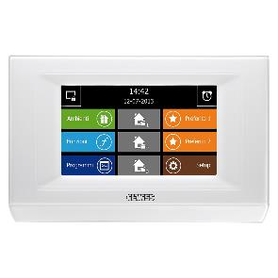
Naxos Domo – The domotics solution
Naxos Domo is the new touchscreen command and visualisation panel with a 4.3“ LCD colour display (16:9 format), that controls all the domotics functions in the home: automations, scenes, temperature adjustment, energy savings, timings, energy management and load control. Available in black or white, and suitable for surface-mounting.
Naxos Combi – The integrated solution
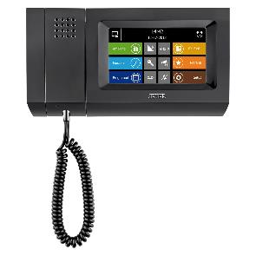
With the Naxos Combi combined touchscreen panel, the basic Naxos Domo functions are further enhanced with those of indoor video entryphone position with speakerphone (with integrated handset), combining KNX domotics with a video entryphone in one single device and offering 2-way interaction between the two worlds. In fact, a video entryphone call can be associated with a domotics action, or vice versa. Available in black or white, Naxos Combi is suitable for surface-mounting.
Comfort, energy savings and safety come together in the domotics panels of the Naxos range. Equipped with an intuitive graphic interface, Naxos Domo and Naxos Combi are able to manage all the domotics functions of the home, from light control (including RGB LED) to roller shutters, from scenes to timers, from logic functions to input/output management.
For the rational, responsible use of energy via the efficient management of the temperature adjustment system and the loads connected to the electricity supply, Naxos Domo and Naxos Combi can also manage an area-based control with probes or KNX thermostats in the various environments, implement the function of up to 4 timed thermostats (with only the temperature measurement received by external sensors on the KNX BUS), control the loads, and manage the energy and consumption in the home.
Finally, Naxos Domo and Naxos Combi satisfy the ever increasing building safety needs thanks to the complete management of the burglar alarm system, the possibility to indicate alarms, the detection of gas and water leaks, etc.

