November 2016
MASTER ICE, THE HEART OF THE HOME
The home environment has never been so pleasant: with the system navigator of the Chorus domotic system, the entire home is constantly under control. Even when you're not there.
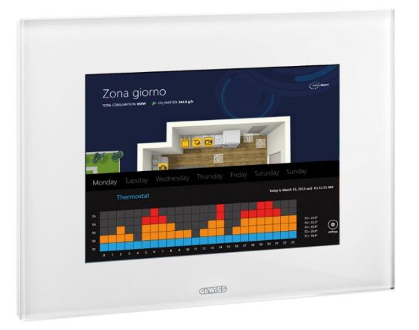
MASTER ICE is the new, beating heart of the modern home; the hub of all the system devices for governing the domestic environment. With the Master ICE touchscreen panel, you can control all the home functions from one single point: lighting devices, roller shutters, air-conditioning system, irrigation system, alarm devices, video entryphone and video control.
MASTER ICE is the ideal system navigator for everyone because it's so user-friendly. Just press the screen with your finger to operate several devices at the same time, display the outside of your home or set the temperature in each room indoors. The new system navigator has a simple, intuitive user interface integrated in the Microsoft® Windows 8 operating environment and, thanks to the multi-touch display, interaction is based on “gestures” that have become habitual with the widespread use of tablets and smartphones.
What's more, the MASTER ICE interface can be personalised with maps, layouts, images or icons to make function visualisation and supervision quick and intuitive. Creating even the most complex scenes is so easy. Alongside the domotic functions, the GEWISS panel adds the possibility to control and manage multimedia contents like video text messages with post-it function, audio messages, media players, web navigation, e-mails, web radio, RSS-FEED.
And it's just as easy to command your home, even if you're not there. With the system navigator you can interact with your home from a distance via the Internet, using a personal computer, tablet PC or smartphone, thanks to WebApp or specific apps. So you can not only receive information via text messages on your mobile phone, but also implement commands and receive the images from the video cameras. All with just a click.
The design of the MASTER ICE system navigator is distinguished by its elegance and linear geometry, offering an overall appearance of balance and harmony.

