November 2016
IN PRAISE OF SAFETY
With the GEWISS interlocked switched socket-outlets, you can live every moment of the day in absolute safety.
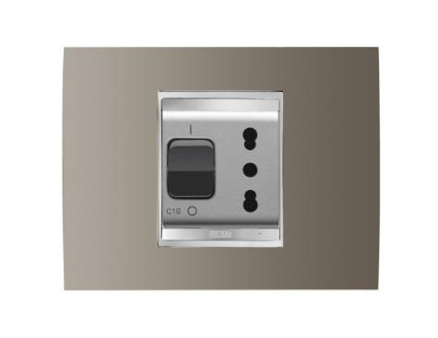
Your home is much more than just the sum of its rooms or the objects in it: your home is first and foremost a private place which cherishes and protects your happiest times and the people you love. That's why safety is a must - to guarantee your loved ones peace of mind any time of the day and in any part of the house.
With a constant focus on the safety of its electrical system, GEWISS has designed interlocked switched socket-outlets to give you the protection you need during power use and take-up, even in rooms like the bathroom and kitchen, where the risk of getting an electric shock is greater, because of water, oil, damp, etc.
Even with careless behaviour (electrical devices used with wet hands or in the presence of liquids) GEWISS interlocked switched socket-outlets guarantee total safety because they deliver power only when the plug is entirely in the socket-outlet; so, unlike a standard socket-outlet, there is no current when the plug is not being used.

