November 2016
HAPPYHOME, YOUR HOME IN A CLICK
HAPPY HOME is the new APP developed by GEWISS for the management of your home from mobile devices (tablets, smartphones).
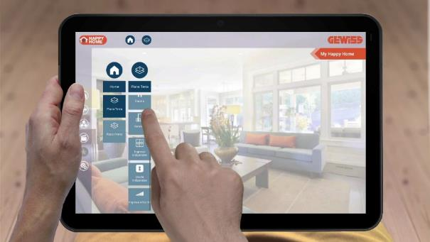
GEWISS home automation management systems are now enhanced with the arrival of HAPPY HOME, the new APP for local and remote management of the KNX and KNX Easy systems from mobile devices (Tablets, Smartphones).
HAPPY HOME allows you to control and display, in a simple and intuitive manner, the lighting, roller shutters, venetian blinds, configure and execute scenarios, adjust the temperature and humidity of each room, monitor energy consumption and manage the burglar alarm.
Characterized by a captivating interface, with specific commands for each type of object to be controlled and to display, HAPPY HOME makes extremely easy use of the domestic function. Surfing the APP is extremely intuitive, thanks to the possibility to customize the interface with background images (for tablets) and icons, as well as save in the Favourites tab commands frequently used for a quick recall. Menus, descriptions and commands are available in 6 languages (Italian, English, French, German, Spanish and Portuguese) to provide full access to all users.
HAPPY HOME allows you to connect and control multiple houses, wherever you are. The APP provides real-time access to the KNX system, both locally via the home WiFi network, as well as remotely via an Internet connection.
HAPPY HOME is developed for Android and iOS smartphones and tablets and is available for free. The APP can be used with any KNX installation equipped with GEWISS' KNX/IP interface. For that reason HAPPY HOME is the cheapest solution on the market to control and manage the home automation system from mobile devices, fully exploiting the comfort potential of a highly evolved home system.

