November 2016
CHORUS GEO, ESSENTIAL SIMPLICITY
The style of the GEO plates was created to satisfy the needs of contemporary design. The rationality of the rectangular shape is enhanced by the lightness and simplicity of the surface that frames the command buttons.
The new GEO plate, with its classic and regular lines, fits perfectly in any environment with simplicity and style. The materials and colours contribute towards creating the right harmony that lasts over time. Made of technopolymer, GEO resists both sudden shocks and everyday strain. Lightness takes form also with reduced thickness which minimises the protrusion from the wall.
The ten different colours (white, black, ivory, hemp, titanium, slate, chrome, gold, ruby, sea blue) and the simple and light forms make GEO a young and informal design element that conveys a minimalist feel in every room.
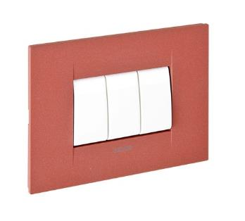
Available in 2, 3, 4 and 6-gang versions, GEO can be perfectly integrated into the CHORUS international domotics system from GEWISS, which was designed to create an infinite number of combinations. Adaptable to the support of the other plates, GEO offers a new style without having to change the core of its operations: the front coupling makes installation operations quick and easy, facilitating assembly and wiring even after the support has been fixed onto the box. Thanks to the flexibility of the CHORUS system, plates can be replaced easily without making changes on the support.
The plate button keys are available in different colours: glossy white, painted titanium and black. Plus, GEO makes it possible to combine the keys of ½, 1, 2 and 3 modules, installing the number of push-buttons needed, and optimising spaces as required. With GEO, as with all the other plates in the CHORUS domotics system, you can select larger button keys for commanding the functions used most often and the compact button keys to better use the available space. The GEO supports are characterised by a half module pitch that allows the assembly of both the innovative compact commands as well as 2, 3, 4 or 6-gang plates.

