November 2016
CHORUS FLAT, A TOUCH OF CLASS
CHORUS FLAT is a detail that enhances your space. A new style now enriches the CHORUS international domotics system: a new line of plates with larger sizes, but that are lighter and thinner.
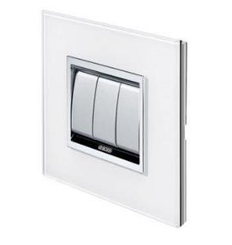
Beauty is the result of a balance of proportions. Every form, every line, every shape that fills space lives in relation to its surrounding context. Beauty derives from this relationship, from the balance between the part and the whole, the detail and the entirety, what is finite and what is infinite.
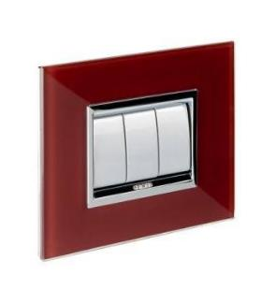
The extraordinary dimensions of FLAT transform daily living areas into wonderful scenes. Larger and thinner, FLAT is designed to meet the needs of superior contemporary architecture. The geometric rationality of the rectangular shape is enhanced by the lightness and simplicity of the surface that frames the command push-buttons. FLAT becomes a decorative element for modern houses, villas, penthouses, lofts and open-space areas. FLAT's style is also easily integrated in recreational structures and restaurants with a strong aesthetic impact. Available in various materials and colours to suit all tastes, they become a design element where light, colours and furnishings work together to create refined environments.
CHORUS FLAT is gratifying to the eye and pleasant to the touch. From wood to glass and metal: authentic and refined materials used to establish continuity between the push-buttons and the design solutions in every room. The FLAT plates offer 20 different colours, each of which offers the right colour balance. And that's not all. FLAT also makes it possible to customise the materials to suit your design requirements.
The plate button keys are available in different colours: glossy white, simple and subtle; painted titanium, refined and exclusive; satin black, modern and elegant. Plus, FLAT makes it possible to combine the keys of ½, 1, 2 and 3 modules, installing the number of push-buttons needed, and optimising spaces as required.
With FLAT, as with all the other plates in the CHORUS domotics system, you can select larger button keys for commanding the functions used most often and the compact button keys to better use the available space. The supports are characterised by a half module pitch that allows the assembly of both the innovative compact commands as well as 2, 3 or 4-gang plates. ONE, LUX, FLAT, ART and GEO use the same support that is universal for the CHORUS domotics system plates.
The front coupling of the devices makes the installation operations quick and easy, facilitating the assembly and wiring phases even after the support has been fixed onto the box. Thanks to the flexibility of the CHORUS system, the plates can be replaced easily without making changes to the support.

