November 2016
SOLUTIONS FOR ENERGY EFFICIENCY
The solutions of the GEWISS domotic system for reducing consumption levels in the home.
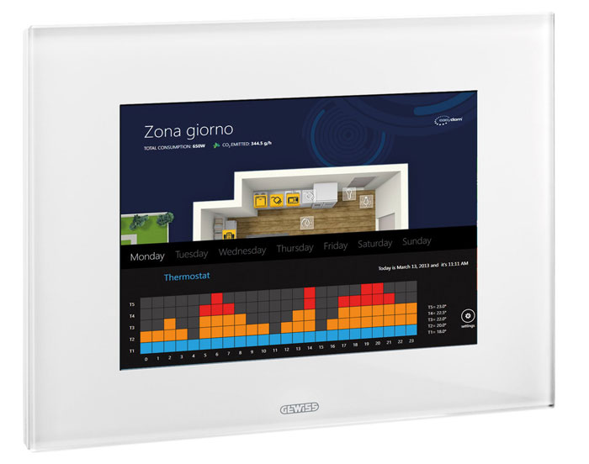
CHORUS is the GEWISS domotic system compatible with international standards and offering a solution for every possible home-related need. Thanks to a model in which every component is separate but dialogues and is integrated through its interaction with the others, CHORUS guarantees an infinite number of combinations that can be used to suit every individual need, ensuring that the system can be expanded and new functionalities can be introduced at any moment.
CHORUS's standard domotics offer is designed for systems in residential and commercial buildings. All of the traditional products that make up the domestic range can be combined with wireless burglar alarms and a wireless command and control system. The standard domotics offer makes it possible to use a mobile phone to remotely control all the main functions of the system: lighting devices, roller shutters, burglar alarm, air conditioning, video entryphone, gas or water leaks.
Energy savings, personal well-being, bio-compatibility, protecting the environment. The CHORUS System makes all of this possible. Just a few simple devices allow the smart control and management of energy consumption in the home, ensuring notable savings on the costs of lighting, heating and air-conditioning.
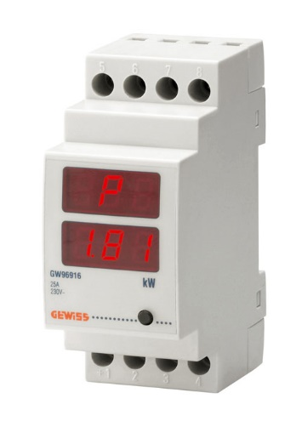
SMART LOAD CONTROL
P-Comfort is a device that can be installed in the conventional domestic enclosure for the smart management of the electrical system power.
If several domestic appliances are switched on at the same time,
P-COMFORT activates a buzzer and an optic warning signal
to inform the user that the energy consumption limit is being exceeded. In this way, the user only has to deactivate one of the appliances to bring the consumption level back below the permitted threshold.
If the overload continues however, P-COMFORT does not cut off the power supply to the entire home but only to the non-priority appliances (as chosen by the user himself), autonomously reactivating them after a pre-fixed time gap.
For example, if the electric loads of the bathroom are set as non-priority, and the oven and hair-dryer are subsequently used at the same time (and there is no direct intervention), only the current to the hair-dryer will be cut off; the oven and other kitchen appliances will carry on working as usual.
This means everything will continue working in the normal way, and the home will not be plunged into darkness. In addition, the display on the device lets you view and keep under control the level of power absorbed by the home at any time. This means a greater awareness of the energy consumption levels in the home, encouraging a more rational use of energy to avoid useless waste.
SMART TEMPERATURE ADJUSTMENT
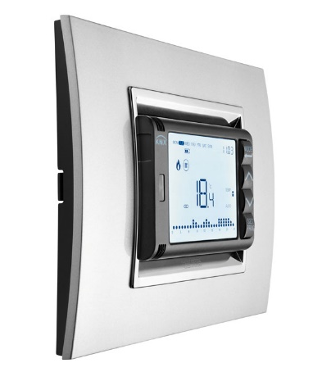
The range of Chorus domotic devices for temperature adjustment in buildings now includes a new assortment of flush-mounted products based on the KNX international communication protocol. They're available in a colour palette of white, black or titanium. The new GEWISS temperature adjustment system is a smart way to control the temperature in the home: at any time of the day or night, you can set climate control systems to just the right temperature, without any unnecessary waste of energy.
The new KNX range includes: a timed thermostat, standard thermostat and temperature probe. These three devices, when appropriately combined, can handle all application requirements. The products are ideal for managing single-stage or dual-stage temperature adjustment systems (systems with a high degree of thermal inertia), whether conventional (with heating elements), floor-mounting, with fan coils, etc.
LIGHT SENSITIVE SENSOR and MOVEMENT DETECTOR
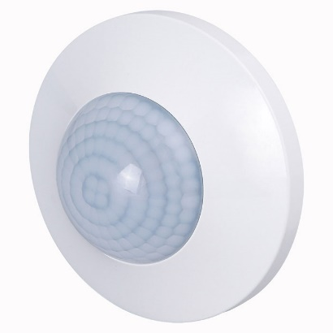
With the light sensitive sensor, that also acts as a movement detector, you can reduce consumption levels in the building and improve the degree of comfort. Installed in every environment and connected to the domotic system, the sensors notably reduce electric consumption with regards lighting: the lights come on automatically and for a specific time when someone passes by, but only when the natural light is inadequate.
The device is the ideal solution in situations where the lighting level has to be kept constant (shops, commercial buildings, public offices, etc.) or in transit areas where the light only needs to be activated temporarily: the light threshold can be freely defined and set on the basis of specific needs.

