November 2016
CHORUS, DOMOTICS ACCORDING TO GEWISS
The new CHORUS domestic system offers advanced solutions for home and building management and control by integrating advanced technology with Italian design.
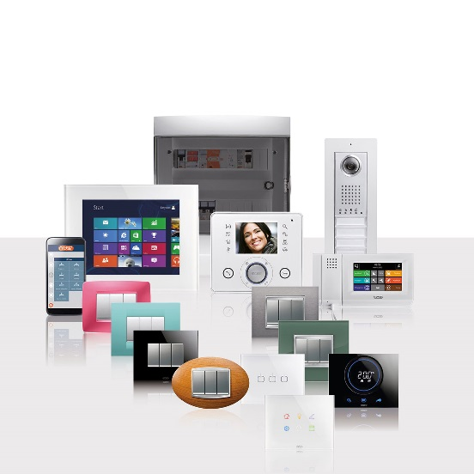
THE CHORUS DOMOTICS SYSTEM is compatible with international standards and offers solutions for various residential needs. Thanks to a model in which every component is separate but dialogues and is integrated through its interaction with the others, CHORUS guarantees an infinite number of combinations that can be used to suit every individual need, ensuring that the system can be expanded and new functionalities can be introduced at any moment.
CHORUS's standard domotics offer is designed for systems in residential and commercial buildings. All of the traditional products that make up the domestic range can be combined with wireless burglar alarms and a wireless command and control system. The standard domotics offer makes it possible to use a mobile phone to remotely control all the main functions of the system: lighting devices, roller shutters, burglar alarm, air conditioning, video entryphone, gas or water leaks.
Energy savings, personal well-being, biocompatibility, protecting the environment. The CHORUS System makes all of this possible. An integrated system of functions that permit sensible use of energy and therefore savings in the consumption of precious assets such as electrical energy, water and gas. Without giving up anything, and without any useless complications, simply by selecting a technology that makes it possible to use natural resources in a more responsible and effective manner.
Today, there is a system that ensures maximum well-being and maximum respect for the environment. That system is CHORUS.

