July 2017
DAHLIA, ESSENTIAL SIMPLICITY
GEWISS presents its new range of plates: a clean, rectangular shape enhanced by a smooth, contemporary finish, to frame controls with style.
DAHLIA is the new wiring device system designed by GEWISS, bringing a touch of class to the contemporary home. With an elegant appearance and classic shape, DAHLIA complements the decor of your home with minimal and sophisticated forms. A simple and discrete Italian design that offers a sense of harmony and aesthetics to residential spaces. The clean, rectangular shape is enhanced by a smooth, contemporary finish, to frame controls with style.
Dahlia lets you express your personality with many colour options - a signature feature of the new GEWISS plates: White, Ivory, Light Grey, Hemp, Dark Grey, Cream, Anthracite Grey. Switches too, can be added in two shades, white or ivory, so you can choose your preferred combination for the control point.
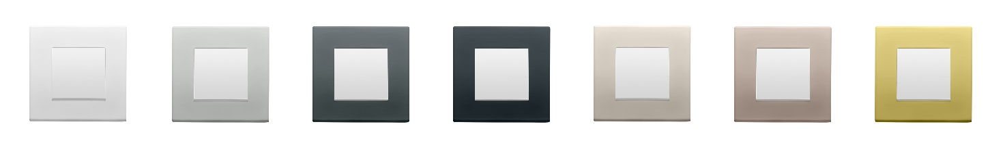The range offers a combination of styles, and also functions as Dahlia can adapt to your specific home automation management requirements, providing a wide range of configurations: the modular design of the plates offers versions from 2 to 2+2+2+2+2 gangs, or double-plates for double-sockets. Furthermore, Dahlia can be oriented vertically or horizontally, minimising the number of product codes and making installation easier.

