November 2016
SMART TEMPERATURE ADJUSTMENT
Comfort, energy savings, remote control and design: with the new KNX temperature adjustment system from GEWISS, the home becomes smarter and daily life becomes more comfortable.
The range of Chorus domotic devices for temperature adjustment in buildings now includes a new assortment of flush-mounted KNX products, available in a colour palette of white, black and titanium. The new KNX temperature adjustment system is a smart way to control temperature in the home: at any time of the day or night, you can set climate control systems to just the right temperature, without any unnecessary waste of energy.
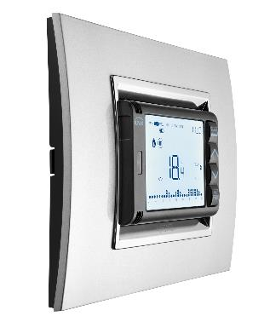
The new range, featuring the KNX and KNX Easy versions, comprises: a KNX timed thermostat, KNX thermostat and KNX temperature probe. These three devices, when appropriately combined, can handle all application requirements. The products are ideal for managing single-stage or dual-stage temperature adjustment systems (systems with a high degree of thermal inertia), whether conventional (with heating elements), floor-mounting, with fan coils, etc.
The KNX flush-mounting timed thermostat ensure excellent application flexibility. It can be set, in fact, in autonomous control mode to autonomously manage the temperature adjustment system (or parts of it), or in Master mode to work with the thermostats to create multi-area systems. The presence of a relay output enables the direct command of the solenoid valve or other generic loads, while the possibility to activate up to 10 independent and freely programmable hourly profiles lets you manage KNX actuators (irrigation, timed lights, etc.).
Certain style and technical features make the device particularly original: the LCD display with RGB back lighting can be personalised with various themes (background colour and icons). The extractable front facilitates the programming of the timed thermostat: you can set the required parameters while holding the device in your hands. The two AA backup batteries ensure that the date and time is stored even in the event of a blackout.
The KNX flush-mounting thermostat can work in two control modes: autonomous, for autonomously managing the temperature adjustment system (or parts of it), or Slave (for multi-area systems). With a relay output for directly commanding the solenoid valve or other generic loads, it also lets you visualise and independently modify the parameters of the temperature adjustment probes (up to 4). The possibility to personalise the theme of the LCD display with RGB back-lighting makes the KNX thermostat a visually striking product that adapts perfectly to any room.
The KNX flush-mounting temperature adjustment probe offers the same functions as the thermostat, with the sole difference that it is not equipped with a local display. For this reason, it is always used together with a thermostat, a timed thermostat, or a surveillance system (like the Chorus Master touch panel or the Internet Gateway). The front LED indicates the operating status and the status of the temperature adjustment device commanded (solenoid valve, fan coil, etc.).

