November 2016
CHORUS ONE, CLASSIC YET INFORMAL
The ONE line of the GEWISS Chorus domotic system is suitable for every environment due to its clean and essential forms.
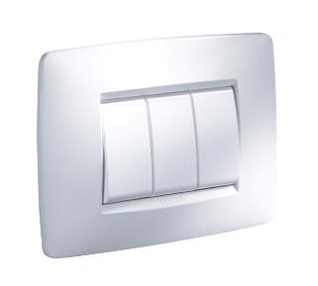
Informal appearance with classic shapes, ONE is the line of plates of the CHORUS domotic system for all those who want to decorate their home with simple forms. The simple and discrete design of ONE enhances every environment, bringing a sense of harmony and design coherency to all environments. Thanks to the high quality of the technopolymers used to make the body, the supports and the button keys, it is able to resist shocks and wear over time.
Available in ten different colour tones (white, black, ivory, hemp, titanium, slate, chrome, gold, ruby, sea blue), ONE can be expressed in every shade, leaving room for fantasy.
As for all the domotics system plates, the button keys are available in different colours: glossy white; painted titanium and black. Plus, ONE makes it possible to combine the keys of ½, 1, 2 and 3 modules, installing the number of push-buttons needed, and optimising spaces as required. With ONE, as with all the other plates in the CHORUS domotics system, you can select larger button keys for commanding the functions used most often and the compact button keys to better use the available space. The ONE supports are characterised by a half module pitch that allows the assembly of both the innovative compact commands as well as 2, 3, 4 or 6-gang plates.
ONE, GEO LUX, FLAT, ART and ICE use the same support that is universal for the CHORUS domotics system plates. The front coupling of the devices makes the installation operations quick and easy, facilitating the assembly and wiring phases even after the support has been fixed onto the box. Thanks to the flexibility of the CHORUS system, the plates can be replaced easily without making changes to the support.

