November 2016
SECURITY FOR THE HOME
GEWISS presents its new wired/wireless burglar alarm system for total home control.
The home has been a refuge and haven since time immemorial: a personal, private place, where the doors are closed to unwanted guests. The concept of the home is closely related to the concept of security, in terms of personal safety and protection from break-ins.
The need to protect the home from break-ins is on the increase and GEWISS has met this need with a new wired/wireless burglar alarm system that combines the safety of wired technology with the versatility of wireless systems. Its new system is stylish and sophisticated, designed for the specific requirements of residential applications.
It is easy to use and quick to install, offering both volumetric and perimeter protection. The GEWISS range includes a modern-style control unit suitable for surface- or flush-mounting, a Touch keyboard with 4.3” adjustable colour screen, a range of wireless devices for extending the system even where it would be difficult to use wired technology, a 2-way remote control with visual confirmation of a received command and a panic function, and an outdoor siren for acoustic and visual alarm signalling.
CONTROL UNIT
The control unit is the real heart of the system; thanks to a simple, intuitive interface, its graphic LCD display provides the user with all the information concerning system operation. The RGB back-lighting can be personalised, offering the user the possibility to associate a certain colour with certain status conditions (e.g. unit activated or deactivated), and the built-in siren warns of events directly on the spot.
The unit is extremely flexible in terms of the number and type of connections: up to 64 inputs are available, and can take wired or wireless devices. Thanks to its considerable installation flexibility and the possibility to manage up to 32 users, the unit is especially suitable for controlling both single apartments and several grouped together.
Depending on the system complexity and the required functions, the system can be configured both manually (using the unit keyboard) and via a PC (using the software included with the CD).
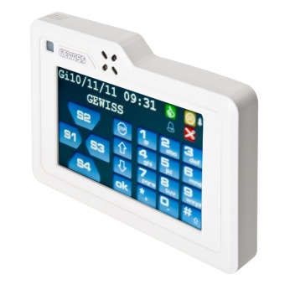
TOUCH KEYBOARD
Some system functions can also be managed from the touch keyboard. The keyboard is equipped with a proximity sensor that allows it to go into standby when no presence is detected. It can command the activation of the control unit, visualise the alarms log (highlighting the date, time and name of the sensor that generated the event), and show the room temperature.
The touch keyboard has a range of additional functions: with “alarm s on map”, you can identify the position of the sensor that generated an event; with “digital frame”, you can view previously-loaded photos in sequence; with courtesy light function lights up the keyboard if there is a voltage failure, to increase visibility in the room.
INTEGRATION WITH THE KNX WORLD AND REMOTE CONTROL
The burglar alarm system can be integrated in the GEWISS domotic system via an optional KNX interface with which you can control the home and activate the protection of any push-button. The interface also lets you associate specific home automations (like the activation of lights in the event of an alarm) with the events detected by the burglar alarm system, thereby increasing the degree of safety of your home.
Finally, the KNX interface also enables the remote management of the system via the Internet Gateway, Master and GSM remote control.

