November 2016
PAVING THE WAY FOR TECHNOLOGY
GEWISS's new underfloor outlet boxes in its 24 SC Range - meeting the needs of the commercial sector.
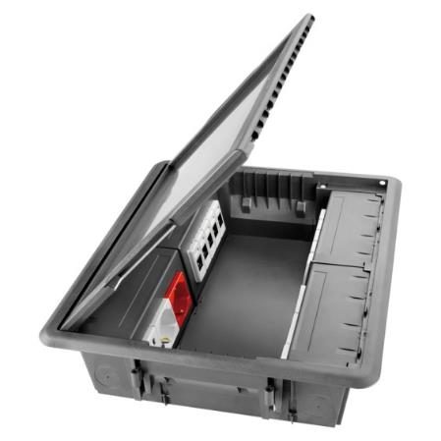
The growing need for protection, connectivity and power take-off in the commercial sector has now been met by GEWISS's new range of underfloor outlet boxes. The extensive, flexible range offers an unbeatable choice of equipment and is ideal for all installation needs.
The new range of outlet boxes is entirely customisable. The capacity, external finishes, internal equipment, opening direction of the cover, and indeed every single part of the outlet box have all been conceived and designed for any environment, to guarantee the utmost practicality all the time.
The 24SC Range comprises 10 and 20 System module outlet boxes, with walk-over cover available as a hollow version, with a selection of finishes (linoleum, carpeting, etc…), or stainless steel version. The cover can be assembled from either side, for opening from either direction, and has been designed for easy removal using a simple tool. To prevent cables getting crushed at the cover closure, there are two slots near the outlet to contain and secure the cables using the ties provided.
The outlet boxes are supplied with unlosable floor fixing clips with a self-positioning system, for extremely quick and safe installation and removal. The outlet box casings are in metal, so that the outlet boxes can also be installed on cast floors, while the retractable handles make it extremely easy to lift the cover.
The new 24SC range is perfect for use with GEWISS catalogue products: components of the System domestic range, as well as DIN rail devices can be housed inside the outlet boxes. Plus the mobile dividers supplied and with two installation positions, mean that data and power take-off components can be combined, and the outlet boxes can be used as electrical system power points and for data networks.

