March 2017

INNOVATIVE SOLUTIONS

Innovation has always been a driving force for GEWISS. This means it develops new solutions that can improve the quality of life.

Innovation and invention are often mixed up or confused, but they actually have very different meanings: invention is related to an idea ('inventors turn ideas into reality'), innovation is related to practice. In fact innovating means more than anything else turning problems into solutions. So innovating does not mean inventing something new at all costs. It means changing and tapping into available knowledge. Innovation is often possible by simply adapting something: a product, a process...

However, to make real progress, innovation must not be an end in itself, as this would turn it into a merely technological action or a pioneering approach. Innovation must be closely linked to the concept of 'value', and namely the usefulness, benefits and costs it generates for customers on the one hand and for companies on the other. A company innovates when its products or services can help solve the problems of its users with new solutions and improve their quality of life.

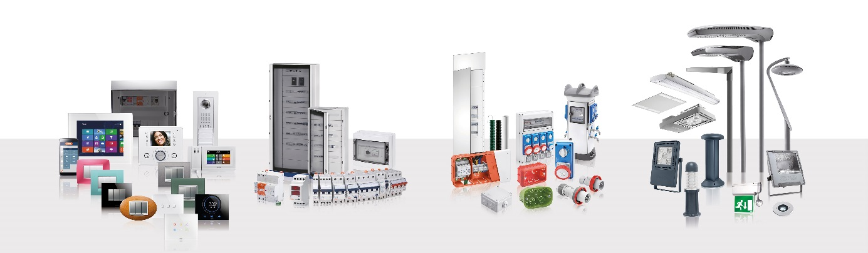GEWISS' commitment to innovation is renewed each year, with solutions and market services designed to make the working life of all industry professionals easier. Only GEWISS can offer this, thanks to a company philosophy with development at the very heart of its operations and continual investments in new technologies - factors which have made GEWISS such a distinctive brand, and synonymous with safety, design and practicality.

GEWISS has always focussed on improving the quality and safety of its systems: innovation is the strategy it has chosen, proposing solutions that meet the needs of the market and anticipate its requests. Thanks to operative support from the Research & Development Department, and considerable investments made in the last ten years (140 million euro), GEWISS has been able to expand its product range to create an integrated electrical system.

THE RANGE

GEWISS solutions are fully optional, with more than 20,000 products for domotics, energy and lighting to meet all needs of the residential, industrial and commercial sectors in the electrotechnical market. Besides home & building automation systems and video communication systems, the GEWISS product range includes energy distribution and protection systems, as well as systems for urban, residential, street, industrial and emergency lighting.

DOMOTICS

Domotics systems offer cutting-edge solutions for **home and building management and control**. The true strength of all systems and building systems lies in integration of all the systems of the building. The control and integrated, coordinated management of systems means that information and operating status can be exchanged among systems and therefore building/system performance can be improved considerably, in terms of energy saving, comfort and safety. In particular, Chorus improves everyday life, combining design with sophisticated functions for a smart home system. With Chorus, system functions can be supervised and managed either locally by user interfaces or remotely via the Internet or simple text messages. The shapes, lines and materials of Chorus attractively bring together all products of different solutions. The plates are available in six different shapes (ONE, GEO, LUX, ART, FLAT and ICE), in a variety of colours and with hardwearing, exclusive, state-of-the-art materials, along with components in three different finishes and colours (white, black and titanium) for a fully comprehensive range of design solutions that are perfect for all contexts.

POWER

The synergy and integration between the modular and moulded-case devices, distribution boards and cabinets, enclosures and combined boards give life to GEWISS’ **Protection System**. A technologically advanced solution, for every application, ensuring quality, safety, and functionality.

BUILDING

The **connection and distribution** system is the heart of GEWISS’ offer and was the first Italian electrical plant of its kind. A range of junction boxes, special containers, distribution boards and devices for industrial connections. Products designed and built to meet even the most complex requirements.

LIGHTING

GEWISS’ flair for innovation and ongoing commitment to experimenting new materials and technologies are reflected in the continual modernisation of its solutions for the lighting industry. A **global vision of lighting technology** concepts and a style echoing the unmistakable principles of Italian design represent the most intimate and deepest dimension of GEWISS lighting solutions. This perfect chemistry has allowed GEWISS to become a global partner in creating lighting systems designed for every room, every space and every location. In fact GEWISS products are perfect for indoors and outdoors, in industrial contexts, for buildings used for commercial purposes (retail outlets, public buildings) and for sports facilities, as well as for street and emergency lighting. The GEWISS lighting range includes architectural floodlights, residential/urban decorative devices, aluminium and technopolymer floodlights, street lighting and flush-mounting elements for the wall and ground.

INNOVATION

GEWISS has built its success on continuous investment in research and development, in the preparation and training of our staff, and in boosting the capacity of our production facilities. A business approach that allows GEWISS to **anticipate the needs of the market**, open up new opportunities and promote an advanced conception of electrical systems. A commitment to innovation which means GEWISS brand is identified as an international leader in the Internet of Things and smart technologies for home automation and LED lighting. This ability to evolve has also been recognized by many international juries: in recent months Thermo ICE received a prestigious IF Design Award 2016, while Smart [4] won the "MIPIM INNOVATION FORUM 2016" competition, the Batimat 2015 Innovation competition and the Socoda Award 2014.

QUALITY

GEWISS devises and developes each process and product so that they achieve the **highest standards of quality** for product solutions. This daily mission, acknowledged by IMQ (the Italian Institute for the Quality Mark) and by the main international Insitutes qualified to certifiy the conformity of the company’s processes and products to standards, has led GEWISS’ laboratories to be awarded with the SMT certification (Supervised Manufacturer Testing). Furthermore, GEWISS guarantees product certification for self-certification and certification by independent parties. This constant drive to change has led GEWISS to reach the prestigious milestone of **400 international patents**. A foundation for innovation that allows GEWISS to take an active part in preparing technical standards.