November 2016
MARKET SERVICES
GEWISS assists professionals in their work and business, thanks to IT tools, training courses, technical customer-services and communication events that promote a culture of a highly-developed system.
Trust is a fundamental part of a relationship between a company and its customers. It stems from an essential requirement: product quality. Without quality, there is no relationship or buyer trust. But product quality alone is not sufficient to win and maintain trust. Quality must be combined with a thorough, comprehensive after-sales service that can assist the purchaser in every stage of the relationship. To sum up, customer care is paramount.
GEWISS has always made customer care a part of its philosophy. Alongside high quality products, GEWISS offers a vast range of services to improve and consolidate the professional standards of its customers and promote the development of their business activities. Behind these services is the conviction that creating and maintaining customer relations is the basis for mutual success. Promoting a culture of a developed system is one way of achieving this aim: with conferences on current issues concerning the electrotechnical industry, regulatory and legal updates and in-depth technical product information about new system technologies, GEWISS supports professionals and increases awareness of the need for up-to-date solutions for systems.
Disseminating know-how to increase customer quality: this is the premise behind the service offered. GEWISS supports the development of professional knowledge in the industry through numerous initiatives including documentation and classroom training, offering the chance to gain essential theoretical knowledge and directly try out the most advanced system technologies.
SUPPORT
Thanks to its technical/sales structure throughout Italy, GEWISS can help professionals in the pre and after-sales phases and in developing custom-made solutions. Through GEWISS Professional Skills Centre GEWISS offers courses for electrotechnical professionals: practical technical courses on domotics for installers, courses on designing advanced systems for designers, sessions on how to add comfort and imagination to buildings for architects. And because professional training starts in the classroom, GEWISS offer trainers’ courses on how to train professionals of the future. In addition, GEWISS offers technical information tools that are quick and easy to use, and technical software which is ideal for preparing estimates and designing electrical systems.
COMMUNICATION
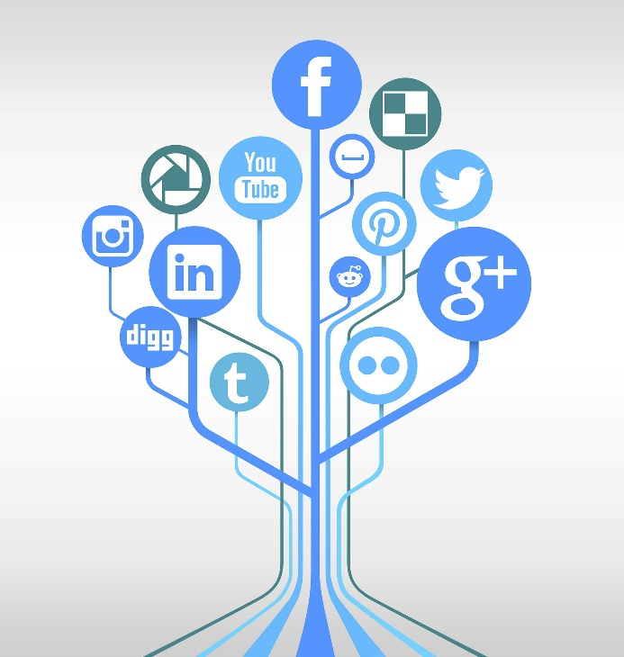
Listening to end users to anticipate their needs and desires; working alongside industry professionals to increase market possibilities; promoting a new culture of systems, to help make domotics even better known. These are the drivers behind GEWISS’ communication strategy. A plan that promotes our culture as a highly-developed system and raises the awareness about the need to adopt up-to-date system solutions. GEWISS’ products are advertised and presented in electrotechnical journals, home/furnishing magazines and the leading women’s lifestyle and information magazines. With the official account on the main social media (Facebook, LinkedIn, YouTube, Twitter, Google+ and Instagram) GEWISS created a new space for discussion and sharing. A multimedia concept, complementary to the GEWISS.COM website, through which you can discover how the home environment can be modified, and share ideas and inspiration to experience your own home in the best way possible.

