November 2016
THE STRENGTH OF SPACE
The new high-capacity, extra robust boxes of the 24 SC BIG BOX range.
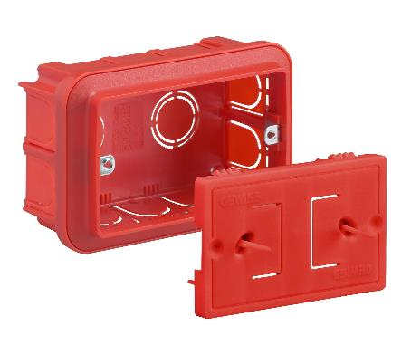
GEWISS has launched the new BIG BOX range of flush-mounting boxes on the market, with a whole host of new features making them the ideal solution for traditional applications, and above all for domotics. Compared to conventional products, the BIG BOX range features an improved box body and even better accessories.
Available in 3, 4, 6, 8, 12 and 18 gang versions, the new BIG BOXES have more inside space (+20%) making them wider and higher and can easily fit wires for conventional wiring and contact interfaces for domotic applications. Thanks to the considerable mechanical resistance to crushing and the use of special double rib metal inserts, the BIG BOXES are extremely solid and robust; plus the sides have holes of differing diameters, easily knocked out and suitable for housing flexible conduits up to ø 32 mm.
The 24 SC BIG BOXES can be used with dividers to create specific areas for circuits and devices powered at differing voltages. Thanks to the joining elements, top-mounted and/or side-by-side assemblies can be created with all the plates of the domestic ranges; with the hooks on the plate, the boxes can be coupled “back-to-back”.
Available as an accessory for the 3, 4, 6 gang versions, the mortar guard guarantees total protection of the box and conduits during plastering and painting. The guard, in reusable technopolymer, is clipped to the outer edge of the box or screwed onto the inserts, ensuring full resistance to the plaster jet. The slightly retracted position prevents interference with the straight edge and makes it easier to remove the mortar.
Its orange colour and recognition sticks ensure the guard can be immediately identified; the flexibility and special orientation of the sticks mean the straight edge can pass over them without any difficulty or spraying. The guard can be easily removed by pulling the central handle or pulling on the identification sticks.

