November 2016
FIRST RATE SOLUTIONS FOR THE BUILDING SECTOR
The flush-mounting systems of the GEWISS GREEN WALL range are purposely designed for electrical systems in buildings with lightweight walls and plasterboard structures.
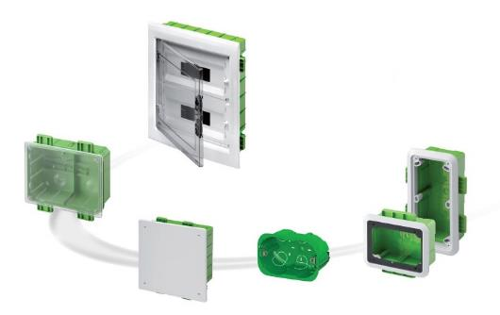
Plasterboard is a material that's widely used in the building and furnishing sector to produce walls, suspended ceilings and raised floors. This type of solution is increasingly popular in both the renovation of existing buildings and the construction of new homes.
These new building requirements highlighted the need for a specific electrical system purposely designed for plasterboard structures. The GEWISS GREEN WALL range is the tangible answer to these new building trends. The system is made up of four product lines: enclosures and boards, junction boxes, boxes for domestic ranges, KNX devices, and boxes for interlocked switched socket-outlets.
The GREEN WALL range introduces the concept of tabs for fixing enclosures, boards, boxes for interlocked switched socket-outlets, and junction boxes. The tab system is a flexible one, suitable for all assembly situations; user-friendly tabs speed up the positioning and fixing of the containers. In the boxes with fixing tabs, the outer edges have specific reference marks for guiding the sheet chasing operation, making it easier to prepare for the cut. The new flush-mounting system from GEWISS is especially suitable for lightweight or plasterboard walls, thanks also to the metal clamps on the boxes for domestic ranges. These clamps ensure safe, quick fixing; it is impossible to lose them and, if they are loosened, they automatically slide into a special seat. Suitable for double-sheet walls too. This mechanism facilitates the removal of the box when necessary.
The various types of fixing offered by the new GEWISS range of flush-mounting systems enable any type of intervention on the walls of the building: on metal frames, masonry walls or sheets.
Enclosures and distribution boards
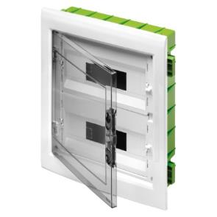
The CDKi enclosures and boards for movable and plasterboard walls have a modern style, with a wide front and an extractable frame suitable for circuit segregation using dividers. The ample space available makes it easy to insert and fix the conduits, and co nsequently to insert the wires and hold all the equipment and its relative wiring in place. The range comes in 5 sizes (12-72 modules). The highly robust smokey grey door is hinged with elastic elements and can be opened to more than 180°. The numerous complementary items guarantee endless configurations for the boards and enclosures. The back-mounting boxes of the enclosures and distribution boards are equipped with special tabs for fixing on metal frames. With the aid of special screws for use with plasterboard, the back-mounting box of the board or enclosure is fixed to the metal frame by means of the tabs. The back-mounting boxes are equipped with cusps for easy sheet chasing in preparation for the cut.
Boxes for modular ranges
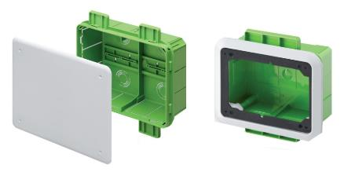
The rectangular GREEN WALL boxes are the ideal solution for the installation of domestic and domotic ranges. The selection contains rectangular boxes for modular ranges of 2, 2+2, 3, 4, 6 and 8 gangs, and special boxes for command panels and touchscreen monitors.
The easy and self-locking conduit infeed system is a GEWISS patent that holds the conduit in place without the use of additional kits. Furthermore, the conduit can be rotated while it is being inserted in the box, making assembly easier. The effective space inside the box allows for easy device wiring, and the extreme robustness and resistance to crushing or mechanical strain ensures the optimum quality and reliability of the products.
Assembly is via the front of the sheet, so the boxes can be easily managed during positioning, maintenance, extensions or renovations. The special conformation of the unlosable metal clamp guarantees the safe, quick fixing of the box, even on double-sheet walls. There are knockout openings on the boxes for housing conduits with a diameter of 20 or 25 millimetres, and opening profiles for conduits of 16 and 32 millimetres. They are positioned in such a way as to make good use of the available space and manage the in-out movement of the conduits in the best way.
Junction boxes and boxes for interlocked switched socket-outlets
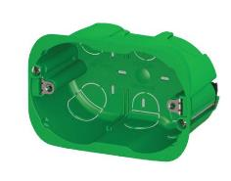
The GREEN WALL family includes standard junction boxes with a DIN rail incorporated on the back-mounting box, high capacity upright boxes, and flush-mounting boxes for interlocked switched socket-outlets (both horizontal 44IB and vertical 67IB).
The standard and domotic junction boxes are available in four different sizes (including one with a transparent cover for controllable equipotential earth nodes), offering ample room for housing and fixing conduits and then inserting the cables. In addition, the DIN rail incorporated on the back-mounting box allows the easy installation of devices and terminal blocks. And the back-mounting boxes also hold specific references for fixing on masonry walls with the aid of wall plugs, with the subsequent positioning of the plasterboard sheets; this is particularly handy in the case of renovations.
The high capacity GREEN WALL boxes are the best solution for creating the system uprights, as they can house a greater number of conduits - even of notable diameter - along the vertical and horizontal walls. In fact, the knockouts on the sides of the boxes are designed for the insertion of conduits and corrugated cable ducts with diameters up to 75 millimetres.
Finally, the boxes for interlocked switched socket-outlets are used for the installation of the vertical socket-outlets of the 67 IB range (AUTOMATIKA, SBF and CBF versions) and the horizontal socket-outlets of the 44 IB range (CBF and SBF versions).

