November 2016
STEEL WIRE - FOR A RAPID, ROBUST SOLUTION
GEWISS presents its BFR range of wire cable trays, suitable for all architectural applications.
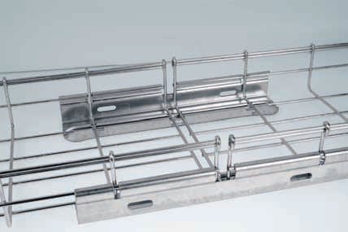
Wire cable trays are a valid alternative to conventional sheet metal systems: their great flexibility and the possibility to easily create bends, changes of direction and ascending/descending sections, make them an ideal solution for all architectural applications.
GEWISS's wide assortment of wire cable trays and accessories is perfect for all market requirements, from small businesses to large-scale industry. The cable trays are available in 3 different heights, 8 widths and 5 standard finishes, including a high protection HP finish ideal for use outdoors. The quality and safety of the cable trays are certified to EN 61537 and by the IMQ quality mark.
Great care has been taken over the installation and assembly stages, that are extremely simple and quick, thanks to a special bracket system, an exclusive press-on fixing cover and quick automatic joints. To make installation and assembly even quicker, exclusive “Speedy Curva” equipment can be used, to cut the cable tray and make flat bends without cuts simply and quickly, saving up to 75% on the time needed to cut and make the bends. The bends made with Speedy Curva deliver considerable benefits in terms of mechanical strength, corrosion resistance, safety for cable integrity and for operators.
Besides their rapid installation, the size of the BFR range cable trays is far greater than the market average: in dimensions most commonly available (height 60 mm) this means more than 40%. The dimensions indicated by GEWISS are in fact the actual internal size (net height and width), so the actual section is far bigger. So with the same cable bundle to lay, a smaller GEWISS cable tray and support size can be selected compared to competitors, with considerable savings.
The BFR range is also extremely safe and robust: the folded edges of the cross wires guarantee maximum cable and operator protection when laying the cable tray (GEWISS patented system), while the double wire at the top of the side guarantees greater rigidity and mechanical resistance to loads.
BFR High Protection HP
The HP finish is an exclusive GEWISS surface treatment, obtained from a special metal protection process that combines zinc and aluminium. The concurrent action of the two elements gives the metal dual active and passive protection against atmospheric and corrosive agents, guaranteeing a longer cable tray life, up to four times greater than hot dip galvanisation.
The coating conforms to Standard EN 10244-2.
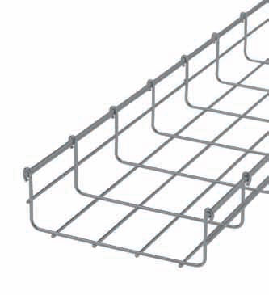
The HP finish has been tested in particularly harsh environments (saline fog and sulphurous atmospheres), to ensure absolute resistance to corrosion, even in the presence of chemical substances and very aggressive atmospheric agents, thus guaranteeing an excellent resistance also in urban and industrial areas with high atmospheric pollution levels.
And that's not all. The HP finish is a particularly cost-effective solution, with savings of up to 15% compared to hot dip galvanisation. Thanks to an automatic universal quick-fit joint, assembly times can be cut by up to 70% compared to traditional joints with bolts. In applications where many kilometres of cable trays need to be laid, such as photovoltaics, this time saving can mean considerable financial savings too.
The extremely high level of protection, combined with quick, easy installation, make the HP BFR range ideal for large-scale photovoltaic sites, where the trays can be used for all cables connecting the panel strings with the inverters.

