November 2016
POWER EVERYWHERE
The GEWISS 68 Q-MC range: six different types of terminals for energy and services distribution.
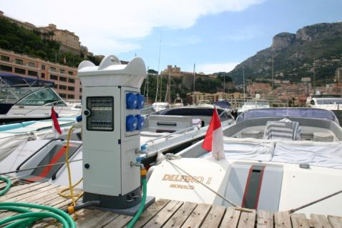
The 68 Q-MC terminals are the ideal solution for electricity, water, signal and data distribution in ports, camp-sites, urban and industrial areas, and even the residential context. The elegant style, materials and colours that distinguish the GEWISS terminals ensure perfect integration with the environment and, at the same time, guarantee the greatest ease of use. The attention paid to the highest quality and safety standards (with certifications) is a guarantee of reliability and of safety for people and objects.
The 68 Q-MC family consists of six different types of terminals with IEC309 standard socket-outlets from 16 to 125 A or with a terminal block output up to 250A and upon request up to 400A; also available in a fire-prevention version, the terminals can be equipped with an electronic control system for recording consumption levels, in the prepaid stand-alone configuration or centralised.
ELECTROPOLISHED AISI 316L STAINLESS STEEL terminals
The electropolished AISI 316L stainless steel terminals are GEWISS's technological solution, combining an attractive appearance with top level technical performance and safety. The AISI 316L STAINLESS STEEL, which is typical for marine environments, has a considerably longer lifespan in heavy duty conditions.
In fact, all STAINLESS STEEL components are subjected to an additional electropolishing and passivation treatment according to the standards of ASTM B 912-02 (Standard Specification for passivation of steel using electropolishing) which provides superior corrosion resistance, further increasing the lifespan. The technopolymer head prevents any risk of burns as it doesn't overheat, even after prolonged exposure to solar irradiation.
Furthermore, its shape makes it possible to store water pipes or cables. The STAINLESS STEEL panels, implemented with an internal isolating coating, eliminate the danger of electric shock and the need for earth connection tests.
Technopolymer versions
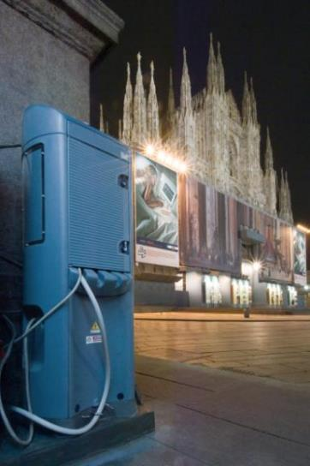
The versions in technopolymer guarantee a high level of resistance to atmospheric, mechanical and chemical agents; the result is obtained by impressing the colour during the moulding phase and by using a blowing technique, for greater impact resistance. The various shades of blue and white echo the colours of the sea and sky, producing an attractive visual effect in outdoor areas. The 68 Q-MC terminals were designed to make the water compartment fully isolated and therefore separate from the electrical circuits; any water leaks or moisture will not jeopardise the safety of people or terminal operation. Also the electric circuits and terminal blocks are closed in separate, watertight compartments to guarantee protection against water, moisture and dust. Versions with electronic control foresee housing in the head of the user interface display, making it possible to calculate power and water consumption. The terminals can be equipped with an electronic consumption control and calculation system in a prepaid stand-alone or centralised configuration.
High capacity terminals
The high capacity versions make it possible to implement terminals for power take-off with industrial socket-outlets or terminal block output up to 250A (upon request up to 400A). The innovative and exclusive retractable door closing system eliminates the risk of shock and provides maximum accessibility to the devices, making it possible to prevent the socket-outlets and modular devices being accessed by unauthorised users. The doors also have a key-operated lock. Finally, the upper part of the terminals are pre-arranged for housing an energy savings lighting kit on both sides.

