March 2017
SIMPLY THE BEST
The 68 Q-DIN range of distribution boards are ideal for the most complex applications.
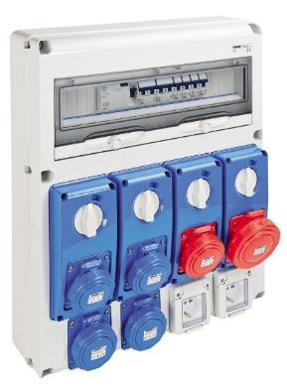
The 68 Q-DIN range is the energy distribution system that is perfect for commercial sector and industrial applications. The range of boards, with 23 versions and 4 modular configurations, from 5 to 20 modules, is highly versatile thanks to the vast assortment of items available and the possibility to have fixed and mobile installations for industrial power take-off (interlocked or otherwise) and domestic power take-off.
The distribution system has been designed to make the work of installers easier: Wiring a DIN board is very easy, thanks to particular devices such as, for instance, the hinged cover opening, the thermoplastic screws, the lack of earth connection due to the Class II classification, the DIN rail adjustable in height, the prearrangement for the insertion of terminal blocks and accessories for the group assembly.
The complete system of industrial boards for energy distribution and controls is available as an empty or wired version conforming to IEC 60439 international standard. The modern design of the boards makes them ideal for any environment, while the ergonomic product solutions ensure an even easier use.
The 20 module versions can house IEC 309 socket-outlets with or without an interlock up to 63A, and without having to add dedicated boards with different sizes; the space inside the boards can house a maximum of 20 DIN modules, and even 40 modules with the additional module.
The 10, 14 and 20 module versions mean that an emergency push-button can be installed in a convenient and readily identifiable position.
The large sized ergonomic handle simplifies door manoeuvring, also when wearing work gloves. The door can be fitted with a safety lock, to prevent access to the compartment.

