November 2016
POWER AND SAFETY EVERYWHERE
GEWISS presents the new family of interlocked switched socket-outlets of the 66/67 IB RANGE.
Interlocked switched socket-outlets represent the main tool for power distribution in areas such as the industrial commercial sector, at worksites, ports, camping, urban areas. For more than twenty years, GEWISS has been the market leader with the 66 IB RANGE which is greatly appreciated by industry professionals due to its robustness, electrical performance and availability at sales outlets.
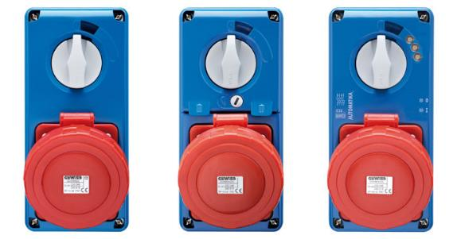
GEWISS presents the new products of the interlocked switched socket-outlet family to provide its customers with products that are aligned to their growing needs and expectations.
Therefore, the 67IB RANGE of vertical interlocked switched socket-outlets has been created, from 16 to 63°, in the following versions:
- with 16A to 63A rotary switch disconnector;
- with 16A to 63A rotary switch disconnector and fuse protection;
- Automatika, with 16A to 32A C6kA characteristic miniature circuit breaker.
Made with high performance, blue thermoplastic material, the new socket-outlets guarantee high impact resistance, UV rays and chemical agents over time.
The patented GEWISS innovations added to the version with circuit breaker protection and to the version with fuse protection revolutionise the interlocked switched socket-outlet protection system. In fact, by integrating the miniature circuit breaker in the fronts of the socket-outlets, boards with minimum wiring can be assembled as only a residual current circuit breaker is required (if not installed upstream). Furthermore, by fixing the switch on the front, GEWISS makes it possible to implement any application, offering in this way a self-protected socket-outlet that represents the solution for all those cases where there is not enough space for new switches on the DIN rails (also in already existing boards). The versions with a fuse-holder use innovative technical solutions connected to fuse access and use, with the self-guided opening of the door, simultaneous isolation of the fuses and manual closure.
The design coordination from 16-63A and the unified dimensions for sizes 16-32A permit qualified installations using the same QDIN boards and accessories; they are perfectly interchangeable with the previous GEWISS SBF range.
Automatika – With circuit breaker protection
The integration of a miniature circuit breaker on the front of the socket-outlet individually protects the load, reducing the spaces on the boards. The control LEDs for each phase of the line are integrated in the front and indicate the operating status of the switch and the presence of voltage. The circuit breaker can be directly reset using the external control handle.
With rotary switch and fuse protection
The innovative fuse holder system makes it possible to automatically extract the fuses from the base by opening the door with a ¼ turn tamper-proof screw. The fuse holder system integrated in the front removes and simultaneously isolates all fuses, making access and the control and maintenance operations easier. The automatic safety closing mechanism prevents the activation of the switch disconnector when the door is not completely closed; the interlock function prevents the door from opening and guarantees IP degree protection.
With rotary switch
The handle was designed to avoid dust from accumulating and to guarantee an ergonomic grip. The handle can also be locked in the ON/OFF position to offer greater safety. The switch disconnector, in the AC3 category, guarantees high electrical performance and lifespan also when controlling highly inductive loads. The hinged opening of the front makes wiring and maintenance easier.

