November 2016
MAKE WAY FOR DOMOTICS
The new junction boxes in the 48 PT DIN range were created to make the installation of domotic systems easier.
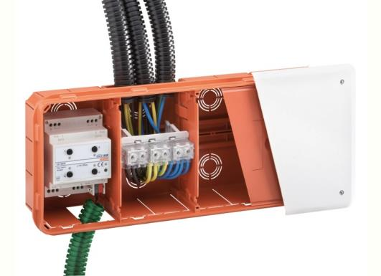
The new 48 PT DIN junction and connection boxes were specifically developed for domotics. In fact, they have the DIN rail directly integrated on the bottom. Thanks to its adequate depth, they permit the optimal fixing of the domotic modules, making use and installation even simpler.
Protective shield. The protective technopolymer shield, supplied as standard, guarantees 100% protection of the box and conduits during plastering and other work phases. Once wired, it offers electric insulation during painting work, even without a cover; furthermore, it guarantees additional acoustic insulation of the box contents (e.g. relays and actuators). The specific teeth on the outer edge make fixing simple by pressing on the edge of the box in a slightly set back position to avoid interference with the straight edge and simultaneously guarantee resistance to the pressure of the plaster casting. For more safety, the shield can also be fixed using screws. The colour identifies the box even after plastering, whereas the central handles make it easy to extract.
Characteristics for domotics
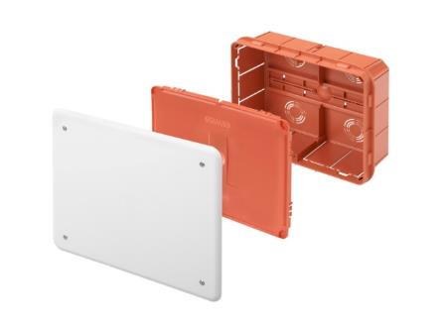
Thanks to the DIN rail on the bottom and the greater depth (75 and 90 mm), the 48 PT DIN boxes can house not only cables, but also actuators and equipotential terminal blocks. An offer that establishes a new market standard, presenting solutions that are suitable for modern systems in the residential and commercial sector. Furthermore, the boxes are prearranged for using dividers, offering the possibility of creating spaces for circuits at different voltages, which is typical for modern systems. The knurled base not only offers greater adherence to improve mortar adherence, guaranteeing greater stability, it has a DIN rail for coupling the domotic modules and the wiring terminals; furthermore, there are also slots for attaching the cable ties.

The cover
The covers have a heat-shrinking film to protect them from dust and contain the bag with the longest and cross head fixing screws (diam. 3x25 mm). The satin finish of the cover's outer surface makes painting easier whereas the greater coverage and rounded profile compensate for any imperfections in the finish between the walls and the back-mounting box.
The terminal blocks
The 4, 6 and 8-way equipotential terminal blocks are compact and can be coupled with each other and/or fixed to the specific support for coupling on the DIN rail. Thanks to the use of the indirect closure terminal, it is possible to offer maximum connection reliability. The transparent shell makes it possible to inspect the connections if needed. Due to their extreme flexibility, they can be used both as earth conductors as well as for phase and neutral distribution.

