November 2016
ROOM FOR TECHNOLOGY
GEWISS presents the new flush-mounting enclosures coordinated with the Chorus domestic system.
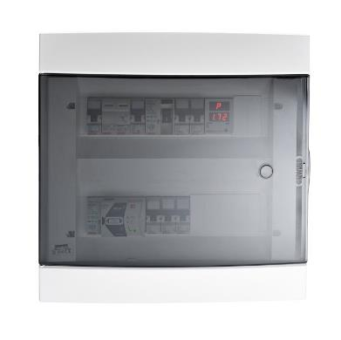
GEWISS presents the new flush-mounting enclosures that complete the 40 CDi family, suitable for installing traditional and domotic system.
The contemporary, linear, refined design of the enclosures, combines perfectly with the shapes and colours of the Chorus domestic range, offering excellent design integration in both the residential and commercial sectors. The technical details of the new design combine practicality with style: The curve of the front and door minimises the overall dimensions, avoids the build-up of dust, ensures notable impact resistance, and enables even the bulkiest devices to be installed; plus, the door is ergonomically shaped at the edge, not only to indicate the opening side but also to provide a safe, comfortable grip.
Available in four colours to produce refined design solutions, the range of enclosures (4-36 modules) allows the creation of general and distribution boards for conventional and domotic systems. The technical and construction characteristics, attention to detail, and complementary items make the installer's work easier: The fronts are compatible with the back plates of the decorative enclosures of the previous range, thereby allowing easy system renovation without the need for masonry work.
The magnetic closure system, available for the 24 and 36 module versions, closes the door gradually and smoothly. The doors can be combined with security locks.
The internal space facilitates the installation and wiring of domotic and protection devices and also help with the passage of cables under the DIN rail.
The new enclosures have a cardboard mortar guard that protects the back-mounting box and conduits during the plastering phase, avoiding difficult cleaning operations afterwards. The back-mounting box is equipped with slotted seats for fixing the DIN rail frame, so the front can be adjusted and perfectly aligned with the wall surface. Finally, door opening has an upper angle of more than 180°, eliminating mechanical stress and ensuring the accessibility of the devices. The reversible front means the door can be opened either to the right or left.

